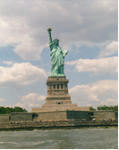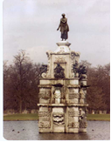

Issue #1 May 2012 Volume #12

Gary Schroeder (55), Editor [gschroeder4@att.net](mailto:gschroeder4@att.net)

Visit the Bushy Park Web Site at <http://www.bushypark.org/>

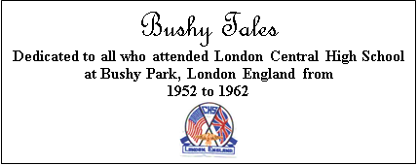

Class Representatives

**1953 - Jackie (Brown) Kenny**

[JKYKNY@aol.com](mailto:JKYKNY@aol.com)

**1954 – Betsy (Neff) Cote**

[betsycote@verizon.net](mailto:betsycote@verizon.net)

**1955 – Nancie (Anderson) Weber**

[nancieT@verizon.net](mailto:nancieT@verizon.net)

**1956 - Edie (Williams) Wingate**

[WingW@aol.com](mailto:WingW@aol.com)



**1957 –Shirley (Huff) Dulski**

[shuffy2@msn.com](mailto:shuffy2@msn.com)



**1958 – Pat (Terpening) Owen**  
[CHS1958@sbcglobal.net](mailto:CHS1958@sbcglobal.net)

**1959 – John “Mike” Hall**

[MGHall@Q.com](mailto:MGHall@Q.com)

**1960 - Ren Briggs**

[rpbjr@frontiernet.net](mailto:rpbjr@frontiernet.net)

**1961 - Betsy (Schley) Slepetz**

[bslepetz@comcast.net](mailto:bslepetz@comcast.net)



**1962 - Dona (Hale) Ritchie**

[DonaRitchi@aol.com](mailto:DonaRitchi@aol.com)

**____________________________________**

**Reminders**

1. We'd love to be able to remember everyone's maiden and married names and the year they graduated. Unfortunately, we can't, so when you send a note for the newsletter (or just a note), please remember to put both your married and maiden name (and if you used another name at Bushy, include that also), also the year you graduated. Thanks.

2. If you stop receiving the newsletter, it's probably not because Gary stopped publishing it. It's because your e-mail address bounced back, and without it we're not able to get the newsletter to you. Therefore, if you're going to be changing you’re e-mail address please let us know so we can change it in our lists. Thanks.

**Editors Note: When sending articles and/or pictures to Pat Owen for the newsletter please use** [**nemoamasa@sbcglobal.net**](mailto:nemoamasa@sbcglobal.net) **email address. DO NOT USE HER OTHER ONE. She only uses that one once a month anything sent there may or may not get into the next issue of the newsletter.**



**Roster Changes**

**New Email address:**



**Look Who We**

**Found**

[](http://www2.free-clipart.net/cgi-bin/clipart/directory.cgi?action=view&link=clipart/Education/Graduation&image=Cap_on_Tombstone.jpg&img=)

**Classmates Who Have Transferred To The Eternal Duty Station**

 **Hearold “H” Baldwin (53)**

I regret to announce the passing of my brother, Harold "H" Baldwin, a member of Central High School's first graduation class in 1953 at Bushy Park.  He passed away in San Antonio, Texas on April 6, 2012 at the age of 76.  After retiring from the US Air Force he worked for the city of Schertz, Texas and the local school district until 1983 when he joined the City Council. Harold was subsequently elected Mayor in 1994 where he served continuously until his death.  A public servant his entire adult life, "Mayor Hal" leaves a legacy of public service spanning four decades as a testament to his love for his community.  The City of Schertz established the "Hal Baldwin Public Service Scholarship" to honor their longest serving mayor.

At the recent Bushy Park Reunion in Tucson, AZ, I was humbled by the donation made by attendees when asked to "Please donate this money to a charity in Hal's name from all of us."

Thank you.

Gary Baldwin (54)

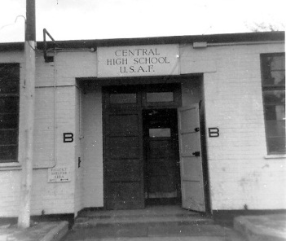

**Memories of Bushy**

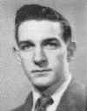**Gary Schroeder (55)**

[gschroeder4@att.net](mailto:gschroeder4@att.net)

One more and then it’s your turn.

You “Dormies” will remember the dances that were held in the Study Hall better than us “Townies”, even though some of us did attend them on occasion.

Some of you should remember this since there were quite a few of you in there that day. On Monday when we got to school the word was that there had been a ‘Barn Dance”, or something like that, held in the Study Hall over the weekend. We heard they had spread hay around to make it more like a barn. It was all cleaned up when we got to school on Monday, or so we thought.

I don’t remember what period it was that I had Study Hall, but I got there just about the same time Bob “Snarkie” Parker and we went to one of the tables in front of one of the windows. It couldn’t be up against the wall because of the radiator sat just below the window. The weather was good, the radiator was not on, so Bob and I opened the two slide-out windows to get some fresh air.

About 15 minutes into the study period Mrs. Walker told us she had to go to the office for a few minutes and we should behave ourselves. Now we all know that wasn’t going to happen, so here is where it starts.

Since the windows were open, there wasn’t a teacher in the room, and we were both smokers why not take advantage of the situation. We both lit up and blew the smoke out the window so no one would know. We were not quite finished when Mrs. Walker came back in and we quickly threw the cigarettes out the window.

Are you starting to get the picture? Yep, here is where it starts getting interesting.

About 2 or 3 minutes after we threw the cigarettes out the window a curl of smoke came up from behind the radiator. That small curl got bigger and bigger and then burst into flame. Bob and I both jump up and holler Fire, Fire and run over and grab one of the fire extinguishers (the kind that are a big bucket filled with water with a top on it with a pump handle running through the top and a hose coming from the side) and run back to the small fire. Bob is pumping the handle like mad and I am pointing the hose at the fire which goes out almost immediately.

Mrs. Walker tells us how brave and quick thinking we both were, and then goes to the Office to get Mr. Farned. He comes in and takes a look and says “There must have been some of the hay they use for the dance left behind the radiator and the radiator had set it off. We need to check behind all of the radiators and make sure there isn’t any more.” Then he turns to Bob and me and says “Your quick thinking just may have saved the school from sustaining serious damage. Thank you. I need to get someone to clean this up.” and he leaves.

Being the quick thinking young men that we were we decided not to mention the fact that the radiators weren’t on. ☺

Anyone have some stories about “Skip Days”?



**Reunion**

**Information**



**Mini**

**Reunions**

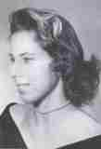

**Pat (Terpening) Owen (58)**  
[CHS1958@sbcglobal.net](mailto:CHS1958@sbcglobal.net)

Pat Terpening (58) and John Owen spent time on Easter Sunday with Fr. Aaron (Sheldon) Peters (57).  We went to Vespers and later had a lovely Easter dinner at the Abbey.  The decorations were beautiful and all done by Fr. Aaron.

After dinner we went out to the bluffs  overlooking the Missouri River and watched the river wend around the bend.  Hard to believe they had bad floods in the same area last year.  A lovely time was had.

Forgot to take the camera, but Pete is doing fine.   Doctor pronounced him cancer free a while back.  He's looking good



**Letters to the Editor**

**Suzanne “Snookie” (Garrison) Mayo (54)**

[sgmayo54@att.net](mailto:sgmayo54@att.net)

Hi Gary, I really like the changes you have made. I was a little concerned when I noticed your picture below the "Classmates Who have Passed on"?? However, I was much relieved to read that you were still with us. I wish we could have found Bob Parker while my brother was still alive. They were such good friends. I do not remember the time you and Bob drove through the halls of Bushy Park on his motorcycle.

I wish you and others could be attending the reunion in Tucson, it should be a fun one.

Thanks again for an interesting issue.

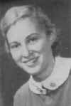**Billie (Culp) Bules (54)**

[DWBCBULES@aol.com](mailto:DWBCBULES@aol.com)

Hi Gary:

I like the new format for the Bushy Tales newsletter. Updating is ok! Thank you for keeping us in touch with each other through the newsletter. You are still "the glue that holds us together".



**Robert E. Kulesh (55)**

[rkulesh@MSEGRIP.COM](mailto:rkulesh@MSEGRIP.COM)

Thanks Gary.. As always a bit of nostalgia and very pleasant memories… Be well and keep up the good work. Best wishes

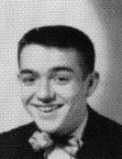

**Phillip “Pete” Laughlin (56)**

[Pmclane@aol.com](mailto:Pmclane@aol.com)

Gary, Love the new look. You da man. Thanks.

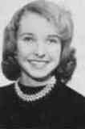

**Sherry “Cheryl” (Buritt) Konjura (57)**

[Sherger2@gmail.com](mailto:Sherger2@gmail.com)

Hi Gary,

Just got the April Issue of Bushy Tales. The new format is very pretty, but it goes too far up the page. When I printed it out it cut off the top 1/2 inch of every page. This never happened before. Don't know if you can correct that using the same format or not. (Editor’s Note: Does anyone else have this problem?)

Loved you motorcycle story! What a hoot and so smart of Bob to take out that pin before Farned caught up with you!

Also, have been enjoying various recollections of the "Smoking Area". Unfortunately, I started smoking at 16 and was one of the ones out there at break time. Fortunately, I successfully quit smoking a long time ago, but I sure do have some pleasant memories of our "gatherings" out there.

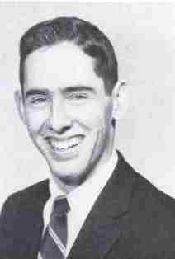**Anthony Taylor (58)**

[usna1964@earthlink.net](mailto:usna1964@earthlink.net)

As always, thanks for your dedication to the task, but I do prefer our old masthead... it is sort of like the Wall Street Journal, once you have a winning look, why change?

**Margaret "Peggy" Jones Howe (59)**

[pjhowe01@gmail.com](mailto:pjhowe01@gmail.com)

Thanks Gary, it's good to get the newsletter. You do a great job with it.

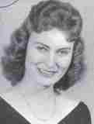**Jean (Lack) Griffing (59)**

[JeanGriffingHomes@carolina.rr.com](mailto:JeanGriffingHomes@carolina.rr.com)

Gary, You have peeked our attention. We are waiting for the study hall and hay story.

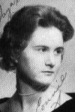**Connie (Newlin) Drennon (60)**

[conniedre@att.net](mailto:conniedre@att.net)

I do so enjoy the monthly newsletter. I still wish I knew the location of the bases were where the dorm folks came from. I also wish I knew of Bushy types within a couple hundred miles of me, here in the middle west. Not sure how that could be accomplished, but might be interesting to try for that, by region. Maybe an outline map

with just the number of known Bushy types in a state, from the addresses you have.



**Harlan Frymire (60)**

[hd@hdfnet.com](mailto:hd@hdfnet.com)

Gary,

Your new format choice is wonderful. Great improvement over the last. Thanks.

**John Frisby (61)** No picture available.

[j.frisby43@verizon.net](mailto:j.frisby43@verizon.net)

I’ve never told you thank you for all the effort you put into the Bushy Park Newsletter but I am now. Also the new format of the April 2012 issue is great. You should know that you are appreciated!

Deadline for articles and pictures for the June 2012 issue is May 20th.

|  |
| --- |
| ***It never hurts to smile at a stranger..... or, You might want to save a life, with a simple kiss....***  ***A tough looking group of bikers were riding through Alabama when they saw a pretty, young girl about to jump off a bridge so they stopped.***  ***The leader, a big burly man, gets off his bike and says, "What are you doing?"* *"I'm going to commit suicide," she says.***  ***While he did not want to appear insensitive, he didn't want to miss an opportunity, so he asked... "Well, before you jump, why don't you give me a kiss?"***  ***So she does... And it was a long, deep lingering kiss.***  ***After she's finished, the biker says, "Wow! That was the best kiss I have ever had.* *That's a real talent you are wasting. You could be famous. Why are you committing suicide?"***  ***"My parents don't like me dressing up like a girl....."***    **"They don't say when the funeral is."** |