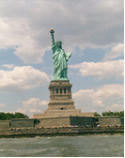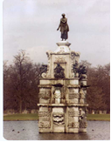

Issue #5 July 2015 Volume #15

Gary Schroeder (55), Editor [gschroeder4@att.net](mailto:gschroeder4@att.net)

Visit the Bushy Park Web Site at <http://www.bushypark.org/>

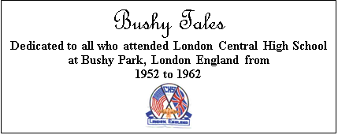

Class Representatives

**1953 - Jackie (Brown) Kenny**

[JKYKNY@aol.com](mailto:JKYKNY@aol.com)

**1954 – Betsy (Neff) Cote**

[betsycote@Atlanticbb.net](mailto:betsycote@Atlanticbb.net)

**1955 – Nancie (Anderson) Weber**

[nancieT@verizon.net](mailto:nancieT@verizon.net)

**1956 - Edie (Williams) Wingate**

[WingW@aol.com](mailto:WingW@aol.com)



**1957 –Shirley (Huff) Dulski**

[shuffy2@msn.com](mailto:shuffy2@msn.com)



**1958 – Pat (Terpening) Owen**  
[nemoamasa@sbcglobal.net](mailto:nemoamasa@sbcglobal.net)

**1959 – John “Mike” Hall**

[MGHall@Q.com](mailto:MGHall@Q.com)

**1960 - Ren Briggs**

[rpbjr@frontiernet.net](mailto:rpbjr@frontiernet.net)

**1961 - Betsy (Schley) Slepetz**

[bslepetz@comcast.net](mailto:bslepetz@comcast.net)



**1962 - Dona (Hale) Ritchie**

[DonaRitchi@aol.com](mailto:DonaRitchi@aol.com)

C:\Users\Gary\AppData\Local\Microsoft\Windows\Temporary Internet Files\Content.IE5\85N5Z4YF\MC900434784[1].png**Roster Changes**

**New Email Addresses**

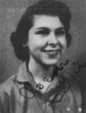

**Billie Jo (Moe) Crouse (57)**

[billiecrouse@gmail.com](mailto:billiecrouse@gmail.com)

**A little reminder to all –if/when you change your email address please let Pat or me know if you want to continue to receive the newsletter. Too many times we only find out when you send us an email saying you haven’t received the newsletter in few months. Thanks guys.**

**[](http://www2.free-clipart.net/cgi-bin/clipart/directory.cgi?action=view&link=clipart/Education/Graduation&image=Cap_on_Tombstone.jpg&img=)**

**Classmates Who Have Transferred To The Eternal Duty Station**

***Our love and prayers go out to the family and friends of our classmates who have gone on before us. We will miss them, yet we can find comfort in knowing that one-day we will all join them for the greatest of all reunions.***



**This is a new column that is strictly for your humble editor to correct some of the mistakes I make in some of the issues – sure hope it doesn’t get too long. ☺**



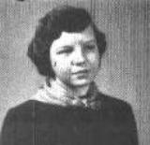

**Beverly (Gehrett) Wagner (58)**

[packrats2@sbcglobal.net](mailto:packrats2@sbcglobal.net)

Just reading the latest Bushy Tales & want to thank you for your faithfulness in helping us keep in touch. I always feel a sense of joy reading the news letter. I am sending a picture of my brother Warren Gehrett, class of '56, & self, Bev (Gehrett) Wagner, class of '58. This picture was taken in 2013, but other than feeling a couple years older, we look about the same. Warren lives in Ottumwa, IA & I live in Albuquerque, NM or El Paso, TX - depending on the season. Easy for me to change location as I still live in my motor home, not ready to settle down yet. Warren & I love getting together & we always spend time reminiscing about our time at Bushy. Warren went on to become a coach at a mid-school in Clovis, NM. Sad to say his wife, Mary Lynn went to her final resting place June 24, 2015 following a lengthy fight with cancer. Warren's computer is down, but if any one wishes to send a card or give him a call, he would appreciate it. Warren Gehrett, PO box 471, Ottumwa, IA 52501. Home phone 641.683.4066. Thanks again for getting Bushy Tales out. Those were the best high school years for Warren & I, he graduated from there in'56, then we went back to the States, much to my regret at the time.

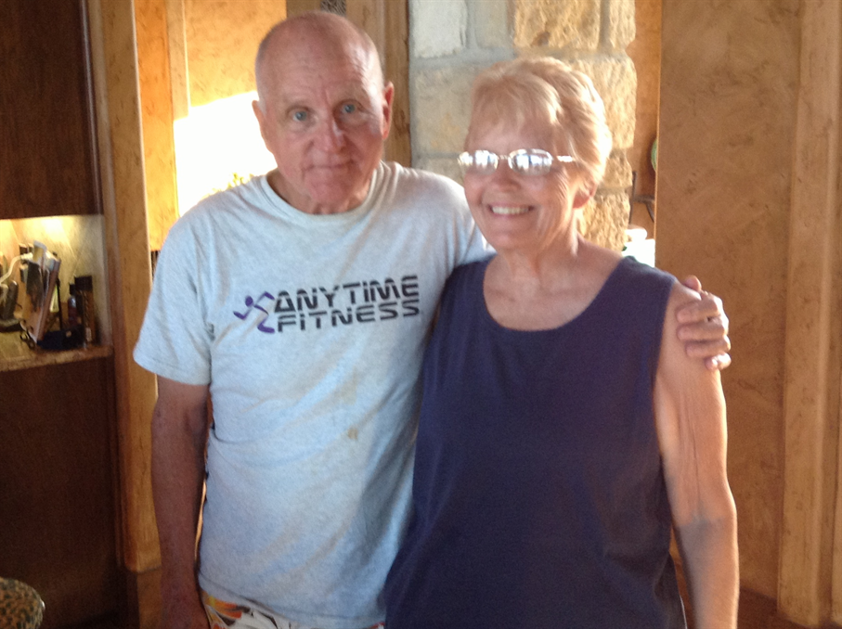

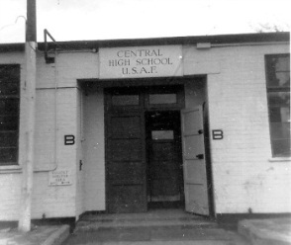

**Memories of Bushy**



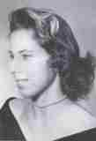

**Pat Terpening (58) Owen**

[nemoamasa@sbcglobal.net](mailto:nemoamasa@sbcglobal.net)

Each month, I’ll give an update on a class, starting with Class of 1953. Those FOUND, DECEASED and FOUND BUT ARE NOW LOST, as well as those who’ve never been found. If anyone has any information on any of those who haven’t been located, it would be appreciated if they could forward it to me (no matter how little it is – either parent’s name, a sibling, anything helps), I’ll then see if I can locate them. Also, if you’d like to contact one of the FOUNDS, just send me an e-mail. Thanks. Pat.

**Class 1958**

**FOUND**

Anda, Alfhild - ME

Apple Shaulis, Paula – CA – Need e-mail addy

Bartlett, William G., Jr – SC – Need e-mail addy

Bass, James R. – TX

Besancon Moore, Lois Ann – RI

Bestwick Newhard, Eleanor – CA – need e-mail addy

Beverly, Robert M. – OK – need e-mail addy

Biggers Potter, Betty Sue – NC

Bois, John – CO

Booth Smith, Joyce –

Brown, Ed - OH

Buhler, Fred – CA

Burnett, Peter – CA

Cameron Rogers, Carol – FL – need e-mail addy

Campbell, Blaine “Chip” – SD

Carr McMahon, Sean – CO

Chilton, Robert - TX

Cooper Cook, Patsy – OH

Crawley, Vince – TX

Culp, Gary – AR

David, Ernest – OR

DeFrees, James – TX

Dilley, Terry – AK

Douglas Roth, Julie – FL

Ellis, Jerry – MS

English Taylor, Virginia – only have an e-mail addy

Fawbush Webb, Patti – TN  
Ferguson, Everett “Doc” – FL – need an e-mail addy

Frantz, Dan – MD

Fricke Gittner, Gretchen – NC

Gath Kakalow, Ingrid – OR

Gehrett Wagner, Beverly – TX

Geyer DeViney, Susann – TX  
Green, James R. – CA

Gruin, Fred – NY

Haave Saunders, Connie – TX

Hannibal, Alex – TX

Hansen Key, Nancy – CA – Need e-mail addy

Harcos Johnson, Mary – CA – Need e-mail addy

Harris, Walter R. – FL – Need e-mail addy

Heck Morris, Joan – IN

Arnold, Henry – WA

Henslee, Gordon Rick “Rik” – CA – need e-mail addy

Hill, Stewart “Skip” – CA

Holmes, Ronald – SC – Need e-mail addy

Hopkins, Robert – CA

Humphries, Bert – CA

Johnson, Thomas, Sandy – UT

Keich, George – PA

Kelly, Jerry – NM

Kimm McAllister, James – MD

King, David – CA

Kirby Jacinto, Nansi – AZ

Knapp Holland, Mary “Joyce” – FL

Kosanke, Frantz, Sandy – MD  
Lane Bailey, Marian – CA

Lawrence Patterson, Althea – CA

Linsey, Dennis – CA

Lund McMahon, Diane – TX

Mabile Pellissier, Carol – TX – Need e-mail addy

Marchant Jennings, Roberta – VA

McClaran Parker, Shari – FL

McClellan Brown, Nettie Grace – FL

McClelland, Robert – OH – Need e-mail addy

McElroy, Stephen – TX

McLaughlin, LeRoy “Doc” – CA

McMannis Miros, Mike - SC

Melrose, Robert – NV - Need e-mail addy

Mittelstadt Buchanan, Sandra – WI – Need e-mail addy

Moorman, Mike – FL – Need e-mail addy

Morgan, Bonnie – AZ – Need e-mail addy

Morgan Trapp, Phyllis – AZ – Need e-mail addy

Murphy, Mike – LA

Naldrett Carpenter, Carol – SC

Ness Rodgers, Patricia – IN

Osmundson, Malcolm “Ozzie” – England

Partridge, Stephen – IL – Need e-mail addy

Peterson Stinnett, Lyn – AZ

Petry, Robert – AZ – Need e-mail addy

Reeve Jennings, Peggy – KY

Rodemeyer Witmer, Jan – AZ

Ruddy, Elena – CA – Need e-mail addy

Rumph Butzer, Nancy – NC

Sawyer Huffman, Barbara – LA

Schlussel, Stephen – CA

Sieburth, Frank – CO

Stewart, Charles “Chuck” – MI

Strand, John – TX

Sturm, Gunther – CA

Sweeney, Susan – OR

Taylor, Tony – WA

Terpening Owen, Pat – KS

Thomas, Paul – UT

Tibbets Robinson, Kathleen – MA

Torres Dickson-Armentrout, Mercedes – CA

Vorlander McNeive, Nancy IL

Walters, Tom – Japan

Warner, Stephen - FL

Westin, Paul – NC – Ned e-mail addy

WICHMAN Patton, Suzanne – NV

Wilson, Richard KY

Witzel, Thomas – CA

Wolfe, Willard “Bill” – AR

Young, Ellis – OK

**STILL MISSING**

Allen, Jane C.

Banks, Leon

Bates, Geneva Lydia – I have info she might live in American Fork, UT

Boex, Christiane Dorothea

Bowen, Robert D – Also attended Wiesbaden?

Branham, Arleen

Brooks, Mary

Cain, Elizabeth

Costner, Patricia Geraldine

Curtis, Larry

Dalton, Brian D

Daniels, Betty

Donald, Adrienne

Dutcher, Ruth

Eberghard, Ingrid

Elliott, Tom

Fowler, Deanne

Fox, Beverly Ann

Freeland, Clyde

Galvin, Daniel

Glidden, Delaine

Greer, Virginia

Hale, Rita

Hardy, Judy

Hattaway, Tommy

Hicks, Daniel

Hogan, Ronald

Jackson, Rita

James, John

Lewis, Donald E.

Lloyd, Julius Arthur

Longwell, William

MacLean, James H.

McHenry, June

McVay Sobieski, Marcia

Messinger, Sherman

Mills, John

Mills, June Karen

Morris, Jacqueline

Neal Redman, Barbara

Parker, Henry

Perry, Lorraine

Peterson, Donald A.

Pratt, Stephen C.

Rupp, Barbara A.

Schmidt, Jenifer June

Schmidt, Robert

Schlop, William

Shantz, Frederick

Shuman, Catherine

Shuman, Tommie (girl)

Stark, Robert

Stuart, Warren

Suggars, Pauline

Sword, Melvin

Taylor, Roger

Thomas, Joan

Vaughan, Bonnie J.

Via, Flora

Von Sassenscheid, Roger

Waters, Elizabeth

Watkins, Nancy Ann

Weldon, James

Wheeler, James

Williams, Gertrude

Williams, Nicholos

Wilson, Michael

Wooten, Valerie

**FOUND BUT IS MISSING AGAIN**

Collins, Walter – All I had was an e-mail addy and it’s no longer valid

**DECEASED**

Bailey, Bill (2005)

Basha, Joseph Paul

Batchelor, Cedric V. (2009)

Boyd, Jon Wilmer

Burr, Roger Nelson

Bussler, Graham Arthur

Cantrell/Ludlow, Kristin (2010)

Checkettsw, Marsha

Cherry, Patricia

Clark, Henry

Coleman, Glenda

DeRoberts, Richard “Dee” (1999)

Dilley Bruekner, Frances (1991)

Easley Tidwell, Ruth (2011)

Eng, Stephen (2014)

Francis, Serrye (1968)

Garrison, Judith

Gumm, Paul

Hoss, Glenn – air training accident

Jones, Wendell Oren (2013)

Lawrence Gross, David

Ludlow Ravetz, Kristin (2010)

Maltman, Bernard (1998)

Markus, John (2008)

Martin Hobbs, Barbara (1999)

Matthews, Errol

Rudat Allen, Robyn (2014)

Sather Hill, Carol (2008)

Sparks, Jerry

Teusink Seils, Judy (2005)

Trail, Ben

Vinson, LaDonna

White, Patricia

Williams, Mahlon (2007)

Williams, Parke (1989)



Classmate

Trivia

*(Editor’s Note: Last month we listed 11 trivia questions about our classmates. Below are the questions, and if we received an answer to the question, the answer is shown below the question. Next month we will drop the questions answered in this month’s newsletter and add any new questions submitted by you the reader. If any questions from the original list are not answered by the June issue we will provide the answer in the July issue.)*

**Q 1**.  **Who's father named the school CENTRAL HIGH SCHOOL?**

***A. Dick Wilson (58).  His dad was Commander of Third Air Force at the time.***

**Q 5**.  **One classmate was featured on one of the episodes of THE FBI FILES?  Can you name him?**

***A. Harlan Frymire (60) and I loved the yellow jacket.***

**Q 9**. **One classmate is a member of the Coast Guard Auxiliary and several years ago didn't see an open hatch on a cabin cruiser, fell through it and broke his foot in three places.  Who is he?**



**Aaron “Pete” Peterson (57)**

[aaronosb@hotmail.com](mailto:aaronosb@hotmail.com)

I believe you are the Coast Guard Aux. and Joyce Knapp Holland is one of the authors (Class of '58) she has a couple of books out on the market - they are mystery novels.

Editor’s Note: Right on both counts Pete. You’re humble, but sometimes dumb, is the Coast Guard Auxiliarist that fell through an open hatch and brook my foot in three places. I had been taking a test onboard a friend’s boat and he had gone outside on the deck to do a little work on the engines. Because the sun was shining through the door on the cabin and was causing a glare he closed the blinds on the door to stop the glare and then went outside to do the work on the engines. I did not know at the time that the hatch was just on the other side of the door so when I finished the test and opened the door to step outside and let him know I fell through the open hatch and broke my foot in three places. It was quite a site seeing him and two others trying to get me off the boat and to the car so they could take me to the hospital. Once off the boat they put me in a two wheeled cart and rolled me up the dock to the car.

Quite a site. ☺

**Q 11**. **Which classmate designed the cover for the first (1953) Bushy Park Year Book “The Londoner”? *(In 1957 the name was changed to “Vapor Trails”)***

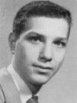

**Richard “Rick” Schroeder (55)**

[sschroe348@gmail.com](mailto:sschroe348@gmail.com)

I created the pen and ink drawing selected for The Londoner’s” first cover; Britannia in the foreground with the Statue of Liberty behind. “Miss Liberty was placed higher so that we could always see her beacon shining on us in Britain from far away home. The Old English lettering (on the original) represented our Colonial heritage.”

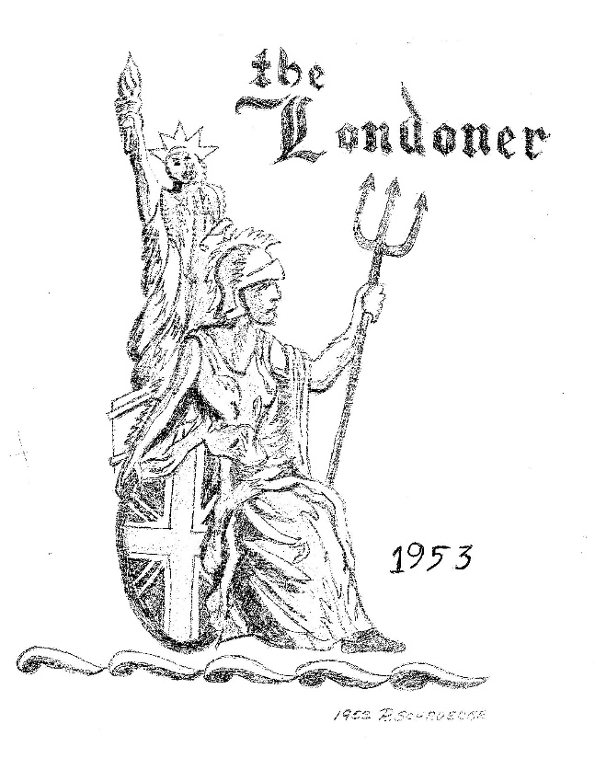

**Q. 12**. **Two classmates (different years) were married on the same day, same year, only not in the same states.  Who are they?**

**A. Helga Blanton (57) and Duane Pepper - Pat Terpening (58) and John Owen  - Helga and Duane were married in Roswell, NM, and Pat and John were married in Las Vegas, NV - both on July 15, 1961.**

**Q. 13 Who named "The Inkling" (the school newspaper)?**

**A. I hope someone out there knows the answer to this one. When doing this newsletter your editor sometimes has fat fingers and deletes things before he should – somehow I deleted the answer to this one before I should have ☹**

**Q. 14 Who was the first male cheerleader in any of the European schools?**

**A. Sheldon (Fr. Aaron) Peters (57)**

**Q. 15 We have classmates in every state except one. Which one does not have anyone from Bushy Park Classes (53-62) living in it?**

***A. North Dakota***

**Next month (August issue) we will have some new questions for you. Hint -how many of you remember the address where you lived in England?**



**Letters to the Editor**

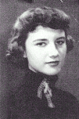

**Suzanne “Snookie” (Garrison) Mayo (54)**

[sgmayo54@att.net](mailto:sgmayo54@att.net)

Excellent, Gary. Clever idea with your questions. We certainly hear from more classmates that way. Pete and I are ready to move back to California if your Texas rain doesn't stop!

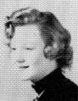**Carolyn (De Vaughn) Floyd (56)**

[d.floyd297@comcast.net](mailto:d.floyd297@comcast.net)

Again, I say thanks for the info. Has anybody found Tim Sutherland, or Babs Smith? I am enjoying recognizing names. Since I was a day student I did not have the close relationships that develop when you are living in the dorms. Tried and tried to get in but I lived in Windsor and my bus drive was 90 minutes each way. Exhausting but I did meet Steve Mc????? Oops, forgot the last name...............................

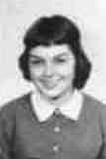

**Sean (Carr) McMahon (58)** [seanloumcmahon@gmail.com](mailto:seanloumcmahon@gmail.com)

Again thank you for continuing to do the newsletter, I really look forward to it.  As for the questions, could Father Pete have been the first male cheerleader?  And the other I think I know is the boy named Hank whose obituary you wrote of recently.  I sat next to him in Miss McFad-

Den's Algebra class, I told you a story about how nice he was (my sister's bout with spinal meningitis) and now I can't remember his name!  The school had a contest to name the new

Paper and I'm pretty sure he won for "The Inkling".  Cheers.

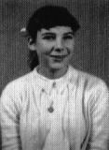

**Felicia (Hardison) Londré(59)**

[LondreF@umkc.edu](mailto:LondreF@umkc.edu)

Dear Gary,

Thank you very much for all the wonderful newsletters! I know it’s a lot of work so I hope you know that it is very much appreciated by silent recipients like me.

I had only my freshman year at Bushy Park, 1955-56, so I don’t have as many memories of it as those who were there longer and had more seniority.

[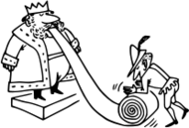](http://www.clipartlogo.com/image/king-and-citizen_157330.html)

**Time for a little Humor**

*Editor’s Note: This one is a little long but so funny there is no way I could leave it out.*

**My Retirement**

After I retired, my wife insisted that I accompany her on her trips to Walmart. Unfortunately, like most men, I found shopping boring and preferred to get in and get out. Equally unfortunately, my wife is like most women - she loves to browse and leaves me with endless time to fill. Yesterday my dear wife received the following letter from the local Wal-Mart:

Dear Mrs. Harris:

Over the past six months, your husband has caused quite a stir at our store. We cannot tolerate this behavior and have been forced to ban both of you from the store. Our complaints against your husband, Mr. Harris, are listed below and are documented by our video surveillance cameras:

**1. June 15**: He took 24 boxes of condoms and randomly put them in other people's carts when they weren't looking.

**2. July 2**: Set all the alarm clocks in Housewares

5-minute intervals.

**3. July 7**: He made a trail of tomato juice on the floor leading to the women's restroom.

**4. July 19:** Walked up to an employee and told her in an official voice, "Code 3 in Housewares. Get on it right away." This caused the employee to leave her assigned station and receive a reprimand from her supervisor that in turn resulted with a union grievance, causing management to lose time and costing the company money. We don't have a "Code 3."

**5. August 4:** Went to the Service Desk and tried to put a bag of M&Ms on layaway.

**6. August 14**: Moved a "CAUTION - WET FLOOR" sign to a carpeted area.

**7. August 15**: Set up a tent in the Camping Department and told the children shoppers he'd invite them in if they would bring pillows and blankets from the Bedding Department, to which twenty children obliged.

**8. August 23:** When a clerk asked if they could help him, he began crying and screamed, "Why can't you people just leave me alone?" EMT's were called.

**9. September 4:** Looked right into the security camera and used it as a mirror while he picked his nose.

**10. September 10:** While handling guns in the Hunting Department, he asked the clerk where the antidepressants were.

**11. October 3**: Darted around the store suspiciously while loudly humming the Mission Impossible theme song.

**12. October 6:** In the Auto Department, he practiced his "Madonna Look" using different sizes of funnels.

**13. October 18**: Hid in a clothing rack and when people browsed through yelled "PICK ME! PICK ME!"

**14. October 22**: When an announcement came over the loud speaker, he assumed a fetal position and screamed "OH NO! IT'S THOSE VOICES

AGAIN!"

**15**. Took a box of condoms to the checkout clerk and asked, "Where is the fitting room?"

And last, but not least:

**16. October 23**: Went into a fitting room, shut the door, waited a while, and then yelled very loudly, "Hey! There's no toilet paper in here." One of the clerks passed out.

My wife has chosen not to ask me to accompany her anywhere anymore!!

**And one more to help fill the empty space**. ☺

**Subject:** Older Brains

Brains of older people are slow because they know so much.

People do not decline mentally with age, it just takes them longer to recall facts because they have more information in their brains, scientists believe. Much like a computer struggles as the hard drive gets full up, so to do humans take longer to access information, it has been suggested.

Researchers say this slowing down it is not the same as cognitive decline.

The human brain works slower in old age, said Dr. Michael Ramscar, but only because we have stored more information over time the brains of older people do not get weak. On the contrary, they simply know more.

Also, older people often go to another room to get something and when they get there, they stand there wondering what they came for. It is NOT a memory problem, it is nature's way of making older people do more exercise.

SO THERE!!

I have more friends I should send this to, but right now I can't remember their names...

So please forward it to your friends, they may be my friends too.

