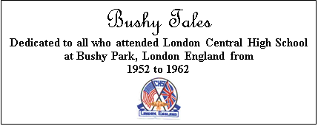

Issue #2 April 2016 Volume #16
Gary Schroeder (55), Founder & Editor (2001-2016) Bill Rumble, Acting Editor
Email: BushyTales1@verizon.net
Visit the Bushy Park Website at http://www.bushypark.org/

CLASS REPRESENTATIVES
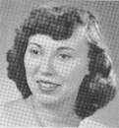
1953 – Jackie (Brown) Kenny
JKYKNY@aol.com

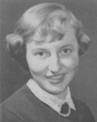

1954 – Betsy (Neff) Cote
betsycote@Atlanticbb.net

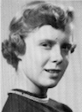
1955 – Nancie (Anderson) Weber
IN MEMORIAM

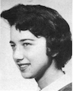

1956 – Edie (Williams) Wingate
WingW@aol.com

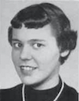

1957 – Shirley (Huff) Dulski
shuffy2@msn.com

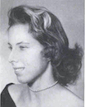
1958 – Pat (Terpening) Owen
nemoamasa@sbcglobal.net

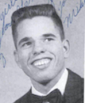
1959 – John “Mike” Hall
MGHall@Q.com

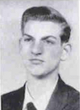
1960 – Ren Briggs
rpbjr@frontier.net

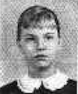
1961 – Betsy (Schley) Slepetz
bslepetz@comcast.net

1962 – Dona (Hale) Ritchie
DonaRitchie@aol.com

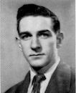

Gerald “Gary" Schroeder

It is with great sadness that I announce that on the evening of
Saturday, March 26, 2016, Gary Schroeder passed away.

I, and I am sure, all those who receive the “Bushy Tales” newsletter extend our deepest sympathies to all of Gary’s family, including his wife, Dee; and his brother, Rick Schroeder (55), and sister, Beverly Schroeder (56) Smith, both of whom are fellow Bushy Park students.

Cards or notes of condolence may be sent to Gary’s wife at the address below:

Debra Schroeder
444 E. Medical Center Blvd Apt #401
Webster, TX 77598-4339

I do not have any further details or an obituary at this time. I anticipate that these will be published in the May newsletter.

I am planning to use the May newsletter as a tribute to Gary and his many years of devotion to the “Bushy Tales” project, which he created in 2001 and nurtured for over 15 years. Please send me anything you would like to include in this issue. It can be a simple email, photos, written recollections of Gary, etc.

Bill Rumble,
Acting Editor

ROSTER CHANGES

PLEASE NOTE: I was unable to deliver newsletters by email to the two following individuals at the email addresses shown. Can anyone confirm for me that these addresses are either correct or provide me with a more current email address for each? I would appreciate your assistance.

Bill Rumble,
Acting Editor

Amorelle “Amy” BUNN (56) FEILLE afeille@moultriega.net

George Keich (58) GEOKeich@aol.com

______________________________________________________________________________
A little reminder to all –if/when you change your email address, please let Pat nemoamasa@sbcglobal.net or me know, if you want to continue to receive the newsletter. Too many times we only find out when you send us an email saying you haven’t received the newsletter in few months. Thanks guys.
_____________________________________________________________________________

Class 1955 Representative Wanted
With Nancie Anderson Weber’s passing, is there anyone among the remaining members of Class 1955 who would be willing to step forward to be Class Representative? It entails very little activity. I add your name, photo and email address to those shown above. Anyone wishing to enquire regarding Class 1955 can contact you. That is unless they contact me. On the other hand, you can feel free to encourage your classmates to do anything related to Class 1955 past or present. I hope to hear from someone in Class 1955 soon.

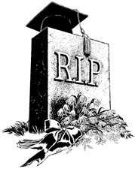
Classmates Who Have Transferred To The Eternal Duty Station

Our love and prayers go out to the family and friends of our classmates who have gone on before us. We will miss them, yet we can find comfort in knowing that one-day we will all join them for the greatest of all reunions.

No others reported this month.
Acting Editor

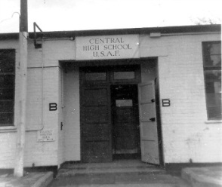
Memories of Bushy Park

Ellen Hollingshead (59) Steele

Hi Bill,

Fred Buhler sent me the latest newsletter. We moved in August from Nevada City, CA, to Lincoln, CA. My email stayed the same, but I no longer received the newsletter.

I attended Central High School my Junior year, in 1957 - 58. My husband, Russ, retired from the Air Force in 1980, and we moved to his home town, Nevada City, CA. In 2006, we started attending the Packing Parties for Friends of the Nevada County Military, which Fred and Margie Buhler founded. Fred and I discovered that we had attended Central High School, and shared many memories of high school in London.

If you could return me to the list, I would be very appreciative,
Ellen Hollingshead (59) Steele emsteele@me.com

Michael Murphy (58)

Thanks for the newest Bushy Tales, Bill. Just a tidbit. I graduated June of 1958 from Bushy Park. Returned to the states, where my dad was stationed in Florida at Homestead AFB. He retired in 1960 and lived in Cutler Ridge, Florida. My 2 brothers, Jack, who died 5 years ago, and my brother George, also attended Bushy Park. Jack graduated in 1957 and George only went there his freshman year. He spent 1955 and 1956 at Bushy Hall. Judy Risler Covington Murphy also attended Bushy Park, graduating in 1960. We live in West Monroe, Louisiana. We recently visited Bill Percy and his wife Donna, who had rented a house in Florida. Spent a week there. We still travel and plan on going to Orange Beach, Alabama, in August. Any BP kids who live there and want a visit, let us know, lol.

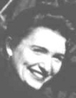
Marcia Craver (53) Thomas

Dear Friends,

I was saddened to read of Nancy Weber's passing. I did not know her in school but we spoke at a couple of reunion meetings and emailed a few times as well. Really pleasant lady who had a good sense of humor as we reminisced about living in dear old England.

I am glad to hear that Gary is doing fairly well at this point and pray that he will be able to overcome this sooner or later.

Also wanted to forward you this story that might be of interest to the BP readers, since some met my mother in San Diego years back, when she attended a reunion with me. She has just turned 104 years and loved her life as a wife of SMSgt Ken Craver, who was my stepfather. He and my husband died within six months of each other in 2002 (as well as two other close relatives) and we have been trying to keep busy every since with my work in theatre and her writing (several books). I have produced a big party each year since she turned 95 and its always a town favorite - people love to come and live it up with her! Each year is a different theme and that ain't easy, because she's traveled and lived in several parts of the world, ridden and elephant, a motorcycle, boated down the Amazon, toured the Eagles Nest in Germany, the Eiffel Tower, Florence, Venice....you get the idea. I was fortunate to be able to travel to some of those destinations for at least two years, while we were in England, but mostly stayed in Texas where I have had at least a regional career as an actress and singer and established two theatre companies (one of which she currently serves as president - the oldest living president of any community theatre in the world!). This year she fell in love with Frank Sinatra again, mainly because of a TV ad that’s been running all year that features his mega-hit "That's Life"......she thinks it fits her perfectly! - So this year it was "Frank and the Rat Pack Invites You to Celebrate Dot's 104th!".....and I did the decorations with that theme with many folks showing up as members of the mob of course and a vocalist who sounded just like Sinatra. She loved every minute of it!

Hope you can use this eventually One of these days I will have more time to write of my wonderful experiences again in London. Gary has used several over the years but every now and then I stumble on something special that stirs my memory of something wonderful that happened and I’ll try to sit down and tell about it whenever I can. Cheerio!

Marcia (McCasland) Craver Thomas, Class of 1953

---------------------------------------------------------------------------------------------------------------------

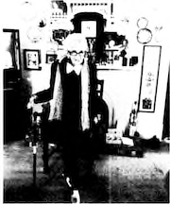
Jefferson's favorite centenarian, Dorothy Craver, was feted with a "Frank and the Rat Pack Invites You" party for her 104th birthday on Saturday at The Black Swan in downtown. Only a few notices for the party were mailed to relatives and out of town friends, but most were informed through social media and internet mail. Friends and relatives, some from as far away as Kansas, Oklahoma and Dallas, came to celebrate Dot's Leap Year birthday replete in costumes and glamour wear for a pretend Las Vegas trip. A specialty 2-tier cake was the centerpiece of the food table and was covered in white sugar icing, trimmed with black tulle banding and black filigree icing with touches of red. Atop the cake was a large red high heel shoe and Roman numeral candles that spelled out 14 instead of 104. A cake made of chocolate cupcakes shaped in the fashion of a ladies corset with black lace trim and red accents, also featured a red high-heel ladies shoe. That cake was dedicated to Dot's great-granddaughter, Catherine Thomas, who just turned 21 years old in February, but was unable to attend the party this year due to
University of North Texas responsibilities, where she is a Junior student majoring in Radio, Television and Film with a 4.0 GPA.

Opera House Theatre Players featured singer-actor John Meyers, formerly of Jefferson, was the entertainment for the event and sang several Sinatra songs, including Dot's favorite, "That's Life", as she did a little dance. A number of videos were taken of the singer and 104-year-old dancer and sent around to several social media sites. Also introduced to the crowd - who feasted on delicious canapés, dips and roll-ups, along with several types of wines and coffee during the evening - was 99 year old Robert Moseley of Louisiana, a long-ago friend of Dot's.
He was accompanied by his daughter Carol, with whom he is currently living. The two spent some time reminiscing about their early days in Jefferson. Mr. Moseley is the oldest living graduate of JHS and Dot is the oldest living former student of the school, having attended in the early first and second grade a in Jefferson but later graduating from Central HS in Ft. Worth.

The party was put together by Dot's daughter, Marcia Thomas, and with the help of Christi and Darrell Gaither proprietors of The Black Swan.

Doris Hayes (59) Jordan

Hi, Bill
My name is Doris Hayes Jordan. I am a member of the Class of 1959. After leaving England, I returned to my hometown-West Helena, Arkansas. I attended AM&N College in Pine Bluff, Arkansas, from 1959-May of 1963; majoring in Elementary Education, with a minor in English and Music. I received my Masters degree from Henderson State University in Arkadelphia, Arkansas, in 1978, majoring in Elementary Education, with a minor in Reading K-6. I am a certified Reading Specialist.

I got married in 1967. My husband passed away in 1985. I have two children, a son who is a mortician and an RN. My daughter is a mortician and is now working on an RN degree. I taught Fourth grade for thirteen years in my hometown. I then move to Arkadelphia, Arkansas, for the balance of my teaching career. However, I did teach my last two years at home. I guess you can say that I made a complete circle. I taught school 45 years. I retired in 2008.

I'm still busy, because we own a mortuary. It has been in our family since 1926. My two children do all of the work; I just supervise. I am licensed to direct funeral services in the state of Arkansas. I spend my time volunteering at the hospital, doing community service with my sorority, and working in my church. I take a trip every January. I am truly enjoying my life.
I enjoy Bushy Tales. A lot has changed since I attended Central High. I was surprised to learn that it no longer is there. I have many fond memories of my time there. Please continue the good work.
Sincerely,
Doris '59

Sue Talbot (53) Camearon

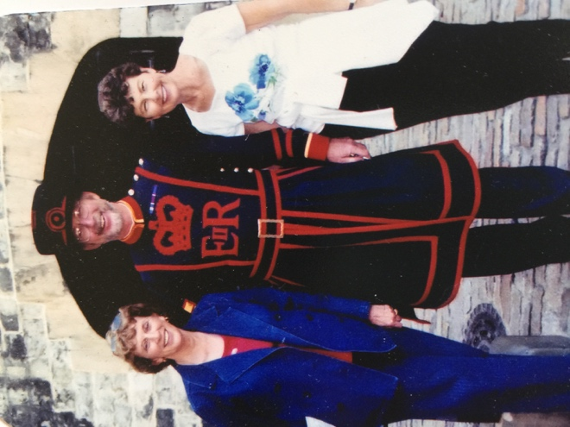
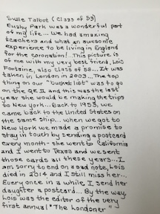

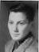
Edward L. Brown (58)

THE DANGER OF ATTENDING A CLASS REUNION AT OUR AGE!
The 60th High School Reunion (or 50th)

He was a widower and she a widow. They had known each other for a number of years, having been high school classmates and having attended class reunions in the past, without fail. This 60th anniversary of their class, the widower and the widow made a foursome with two other singles. They had a wonderful evening, their spirits high, with the widower throwing admiring glances across the table . . . and the widow smiling coyly back at him.

Finally, during one dance, he picked up courage to ask her, "Will you marry me?”
After about 6 seconds of careful consideration, she answered, "Yes.... yes, I will!"
Needless to say, the evening ended on a happy note for the widower.

However, the next morning he was troubled. Did she say “Yes” or did she say “No”? He couldn't remember. Try as he would, he just could not recall. He went over-and-over the conversation of the previous evening, but his mind was blank. He remembered asking the question, but for the life of him could not recall her response.

With fear and trepidation, he picked up the phone and called her. First, he explained that he couldn't remember as well as he used to. Then he reviewed the past evening. As he gained a little more courage, he then inquired of her, "When I asked if you would marry me, did you say “Yes” or did you say “No”?
"Why you silly man,” she replied, I said “Yes. Yes, I will! And I meant it with all my heart!"
The widower was delighted. He felt his heart skip a beat.
Then she continued. "And I'm so glad you called, because I couldn't remember who asked me!”

