Issue #1 March 2016 Volume #16
Gary Schroeder (55), Editor Bill Rumble, Acting Editor, BushyTales1@verizon.net
Visit the Bushy Park Website at http://www.bushypark.org/

CLASS REPRESENTATIVES
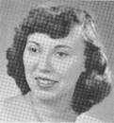

1953 – Jackie (Brown) Kenny

JKYKNY@aol.com

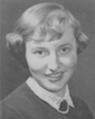

1954 – Betsy (Neff) Cote
betsycote@Atlanticbb.net

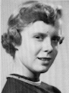

1955 – Nancie (Anderson) Weber
IN MEMORIAM

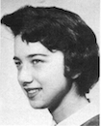

1956 – Edie (Williams) Wingate

WingW@aol.com

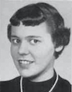

1957 – Shirley (Huff) Dulski
shuffy2@msn.com

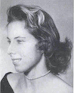
1958 – Pat (Terpening) Owen
nemoamasa@sbcglobal.net

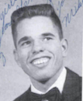
1959 – John “Mike” Hall
MGHall@Q.com

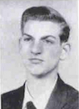
1960 – Ren Briggs
rpbjr@frontier.net

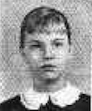
1961 – Betsy (Schley) Slepetz
bslepetz@comcast.net

1962 – Dona (Hale) Ritchie

DonaRitchie@aol.com

Gary Schroeder Status Report – March 1, 2016

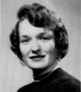

From: Ruth Lund (55) Bethea

News from Gary's daughter-in-law:

"Gary has been unable to participate in his rehab program due to chronic pain, so he is now under comfort care orders. It's still a work in progress, but we feel better with extra eyes on him and he is in less pain.

Gary’s wife has moved, so all cards should be sent to:
444 E. Medical Center Blvd Apt #401
Webster, TX 77598

Please continue praying for Gary, his wife and family. Thank you."
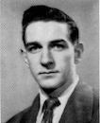
https://www.gofundme.com/ba7c4ccw

_________________________________________________________________
A little reminder to all –if/when you change your email address, please let Pat nemoamasa@sbcglobal.net or me know, if you want to continue to receive the newsletter. Too many times we only find out when you send us an email saying you haven’t received the newsletter in few months. Thanks guys.
_____________________________________________________________________________

ROSTER CHANGES

Classmates Who Have Transferred To The Eternal Duty Station

Our love and prayers go out to the family and friends of our classmates who have gone on before us. We will miss them, yet we can find comfort in knowing that one-day we will all join them for the greatest of all reunions.

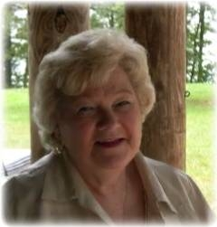
Diane Pendergrass (55) Hopkins
Dianne Pendergrass Hopkins was a native Atlantan, who passed away on February 6, 2016 at the age of 78 years.
Her funeral was held on Tuesday, February 9, 2016 with burial in Floral Hills Memory Gardens, Tucker, Ga.
Mrs. Hopkins was born in Atlanta, Georgia on October 16, 1937. After graduating from Bushy Park High School in London, Mrs. Hopkins married, worked for Southern Bell, became a cosmetologist at 28, and retired from Belk after 12 years. She and her husband, Thomas Edwin Hopkins were married for 32 years before his death in 1989. Her parents, Harold Franklin Pendergrass, Sr. and Estelle Jenkins Pendergrass, and brother Harold Franklin Pendergrass, Jr., preceded her in death. Mrs. Hopkins was a loving wife, mother, aunt, and friend. She will be deeply missed by her many friends and relatives.
Mrs. Hopkins is survived by her son, Thomas Edwin Hopkins, Jr., daughter, Teresa Hopkins Holt (Tony), and daughter Tina Hopkins Ray (Jeff), sister, Linda Pendergrass Hawkins (Bill), sister, Cathy Pendergrass Kitchens (Jimmy), sister, Janet Cook and all of her special nieces and nephews.
Email: tinahray@gmail.com
Cards: 85 Mule Pen Rd
Sylvia, NC 28779

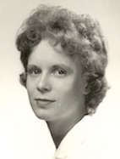
Nancie Anderson (55) Weber
Nancie Weber, 77, died peacefully on Monday, February 8, 2016, at her home in Highland Village, Texas. She was born on February 24, 1938 to Captain Eric Anderson of the United States Coast Guard, and his wife Vera Anderson in Baltimore, Maryland. She was an only child.

She graduated from Bushy Park Central High School in 1955, then earned a degree from University of Vermont where she was a member of the Kappa Alpha Theta Sorority.

She married Paul Weber on July 17, 1960. They had 3 children together and raised their family in various military bases throughout the world. Paul served 2 tours of duty in Vietnam and was a major influence developing GPS for the United States Army. Lieutenant Colonel Ralph Paul Weber retired from the United States Army in 1979.

Nancie enjoyed quilting and spending time with her cats. She was also known to enjoy an occasional martini on the porch.

She was preceded in death by her parents; her husband, Paul; and her daughter Kristin Ilene.
She is survived by her sons, Eric Matthew of St. Cloud, Florida, and his wife Dawn; Dennis David of Copper Canyon, Texas, and his wife Jami; and her grandchildren, Haley Ilene, Kristin Alexandra, Randall Paul, Madison Marilee, Caroline Grace and William James Benton Weber.
Nancie will be laid to rest in the West Point Cemetery at the United States Military Academy in West Point, New York.
In lieu of flowers, donations may be made to your local SPCA in Memory of Nancie Weber.
Cards may be sent to the following address:

Dennis Weber
4565 Mahogany Lane
Copper Canyon TX 75077

This is a new column that is strictly for your humble editor to correct some of the mistakes I make in some of the issues – sure hope it doesn’t get too long.

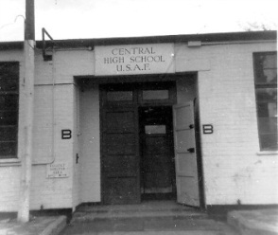
Memories of Bushy Park

From: Jerry Kelly (58)

Hi Bill: I thought that I might send something for the news letter besides the pictures.
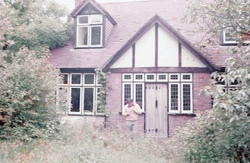
My family arrived in England in November 1956 and dad was stationed at the High Wycombe base and was the manager of the NCO club. We lived in an English house for a couple of months until the base quarters were ready.

This was our house when first arriving in England, Witchwood, Little Kings Hill, High Wycombe. Looks like my brother Mike Class of 61 in the picture.

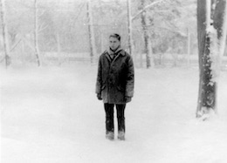
Winter on base at High Wycombe 1957-58

I spent a short time as a dorm student until the school transportation was extended to the High Wycombe base. An hour and a half each way every day. I was in my junior year and, after missing about six weeks of school while in transit, I had to buckle down to catch up with my school work. After graduation in June of 1958, I went back to the states and lived with a married sister near Travis AFB, where we had been stationed for three years. I finally figured out that I needed to get a real job and went to Round Mountain, Nevada where I went to work with my grandfather in a gold/silver mine. This was a large open pit mine with about a hundred employees. My job was in the refinery with my grandfather and another old timer, Eddie Crutchfield. I did most of the heavy work, but one thing was that I cleaned the slag off of the gold bars and sacked them up for shipment to the mint in San Francisco, they went fourth class mail. Most bars were between 450 oz. to 500 oz. The usual shipment each week was four to five bars and the max was nine bars for the week.

When the family rotated back to the states, dad was stationed at Beale AFB, Yuba City, CA. They were back for about a month and I decided to join the Army. Three years in the air defense with two years on a mountain top east of Los Angeles and then transferred to McGregor Range, New Mexico. I was in a support unit issuing every thing needed to prepare the missiles for launch. After separation, went back to California and became a union carpenter for 33 years and retired at age 55. Most of my work was in Commercial type construction with a lot of drywall involved. Toward the end of my carpenter work, I took classes and became a licensed Building Inspector for general building and also in reinforced concrete. Retirement has worked out where I didn't have to fall back on building inspection. I still am involved in building something, be it model aircraft and for the last ten years or so a cabin in south west New Mexico, near the Continental Divide. This project started with an unimproved 20-acre plot of land within a sub-division. There are lots of deer and elk and many other wild animals.

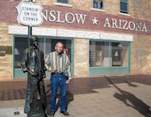
Standing on the Corner with the Man

I have been married 50 years and we decided not to have kids. My wife Sandra retired as a CPA licensed in California and worked 30 years for San Bernardino County. So far no major health issues.

From: Ellis Edward Young (58) (No photo available)

My Dad was stationed at West Drayton and we lived at Laleham/Staines on Thames.

Sandra lived in Staines. We met at age 15 and when she immigrated in 1960 we married at Whiteman AFB, MO. We ended up in Oklahoma City in 1967. Been here ever since. Sadly, she contracted Alzheimer's and lives in a specialized home in Norman, OK.

It broke my heart.

Letters to the Editor

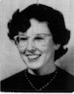

From: Nancy Reed Robinson (56)

Bill,

Thank you so much for getting the information out to all of us. I knew Nancie Anderson in London and also slightly in the US. I enjoyed her company at the reunion that was held in San Diego not so long ago.

Thank you also for sending out the Bushy Tales.

I have just a tidbit for the Bushy Tales.

Last February my best friend, Paul S. Gesswein, graduate of the Naval Academy 61 and neighbor, pinned me. By summer this year we became engaged. He gave me his miniature and then we planned our weddings.

Since in true military tradition we have family all over the country, we planned two weddings. One wedding was in San Antonio, Texas, in September at Paul's sister, Arline Terrell's home, where our 4 siblings (Betty Lu, now Elizabeth Reed '60, Jim Reed '66) could join us and the second was in Reston, Virginia, near where we now live.

Our second wedding was in October and a very youthful event including children, grandchildren, one nephew, many nieces, and even two great grand daughters of mine who are each two years old.

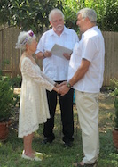
Since we are both in our late seventies we decided to have a movie of our different pasts to catch everyone up on who we are and who we were. Paul shared his part of the Vietnam war which was aboard several LST's and I shared living in London, going a British school there and of course Bushy Park. I lived on the west coast CA, a few years in Texas, and Arizona between 1957 and 1962. Paul had spent a lot of his life from Vietnam to Hawaii while I mostly lived on the east coast since 1963. Paul also worked a lot in Germany. We both know Annapolis, Maryland, pretty well. Both my dad graduated from the Academy in 36 and my grandmother Musterman had a hat shop on Main street.

Best wishes to everyone!

Nancy Reed Robinson (56) Gesswein

--FINIS--

