Issue #8 October 2016 Volume #16

Gary Schroeder (55), Founding Editor (1936-2016)
Bill Rumble, Editor email: BushyTales1@verizon.net
Pat (Terpening) Owen, Assistant Editor email: nemoamasa@sbcglobal.net
Visit the Bushy Park Website at http://www.bushypark.org/

CLASS REPRESENTATIVES
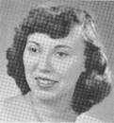

1953 – Jackie (Brown) Kenny

JKYKNY@aol.com

1954 – Betsy (Neff) Cote
betsycote@Atlanticbb.net

1955 – Volunteer Requested
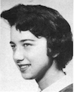

1956 – Edie (Williams) Wingate
WingW@aol.com

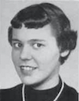

1957 – Shirley (Huff) Dulski
shuffy2@msn.com

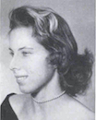

1958 – Pat (Terpening) Owen
nemoamasa@sbcglobal.net

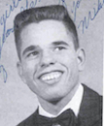1959 – John “Mike” Hall
MGHall@Q.com

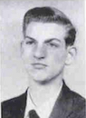
1960 – Ren Briggs
rpbjr@frontier.net

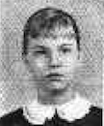
1961 – Betsy (Schley) Slepetz
bslepetz@comcast.net

1962 – Dona (Hale) Ritchie

DonaRitchie@aol.com

ROSTER CHANGES

From: Pat Terpening (58) Owen

_________________________________________________________________
A little reminder to all –if/when you change your email address, please let Pat Terpening nemoamasa@sbcglobal.net or me know, if you want to continue to receive the newsletter. Too many times we only find out when you send us an email saying you haven’t received the newsletter in few months. Thanks guys.
_____________________________________________________________________________

________________________________

Classmates Who Have Transferred To The Eternal Duty Station

Charles “Chuck” Miller (61)
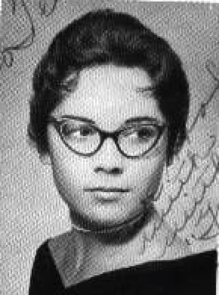I'm sending news of Chuck Miller's death. Sandy Stewart notified me a couple of days ago, and then sent this clipping from the newspaper. It doesn't say the cause of death, but she said it was "unexpected", and she thought it may have been a sudden heart attack.
Judy Risler (60) Murphy

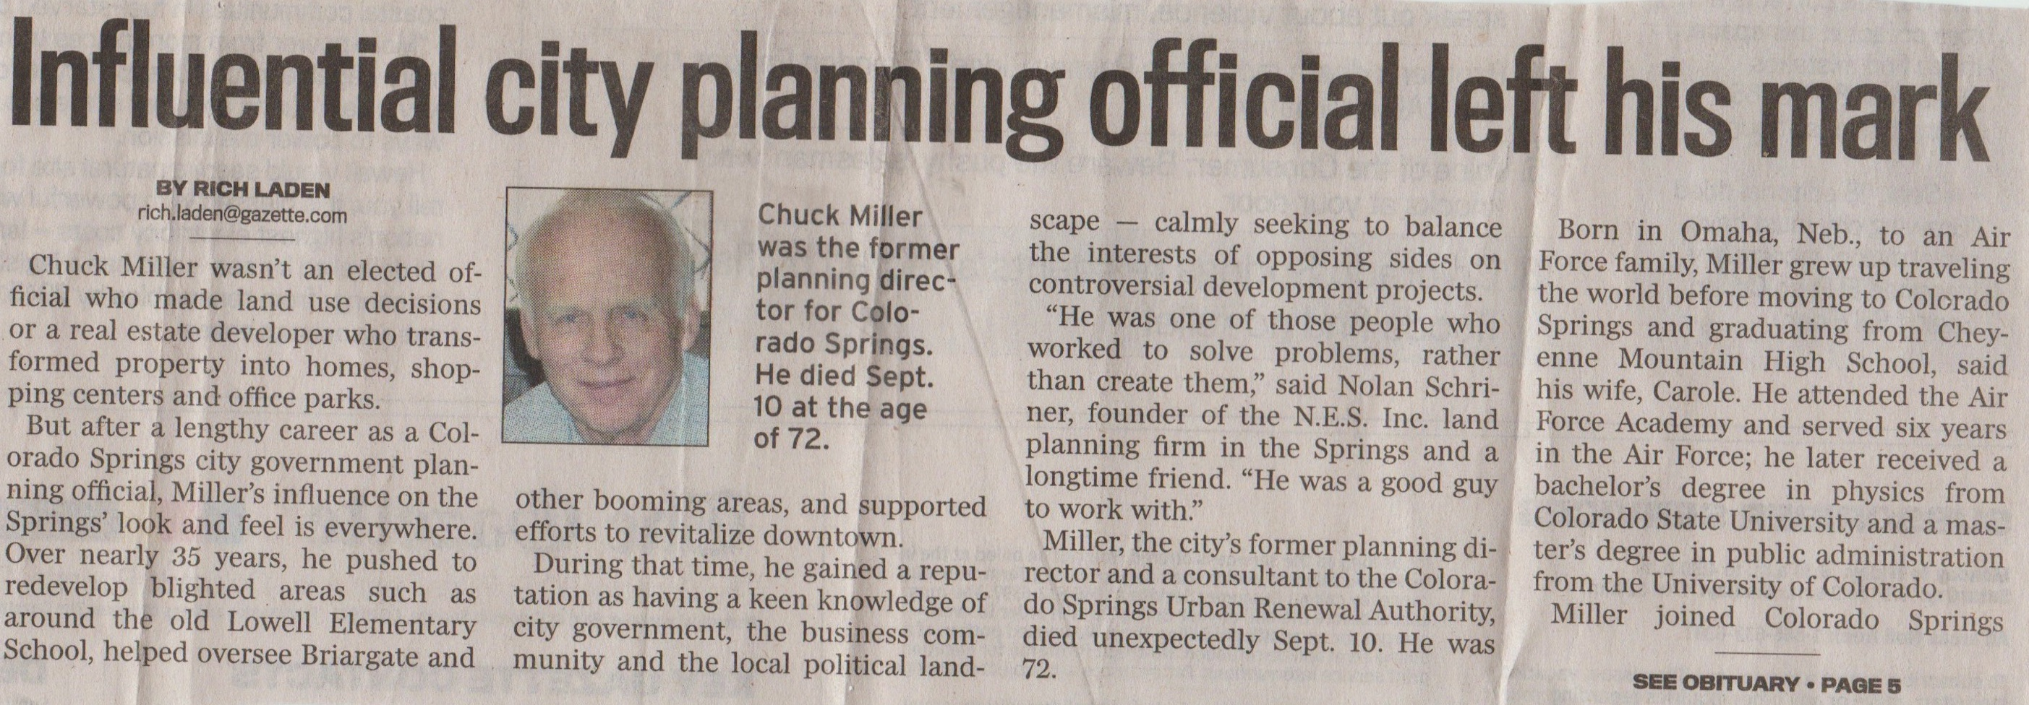

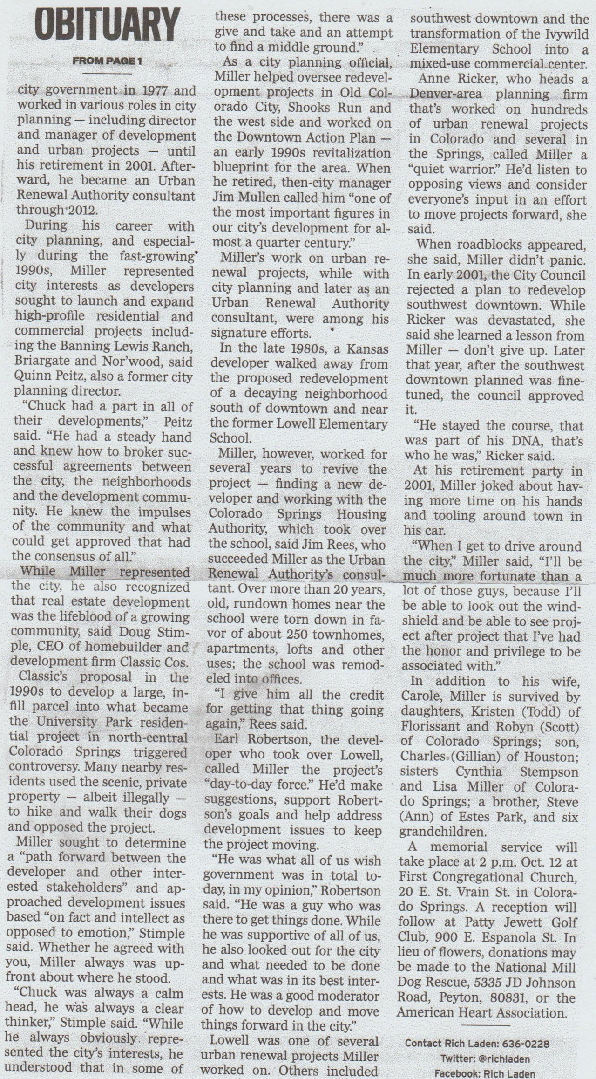
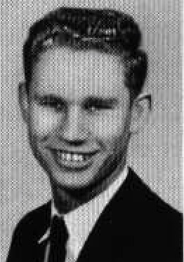Alvin George "Bud" Jordan (1944 - 2016)
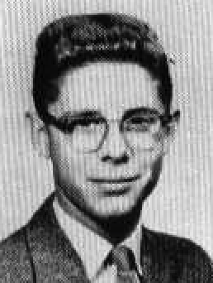I’m sorry to say that I just found out we have lost another Bushy Park classmate. Last week, on the 27th, Alvin Jordan (Class of '62) passed away. During his Bushy Park days, Alvin, was known as “Buddy” Jordan as is indicated in the 1960 yearbook. During the ‘59/’60 school year I lived in the Annex Dorm and Buddy liked to call himself “The Big Bad Wing Chief” for our wing of the building. While I am having somewhat of a lapse in memory of that period, I do remember he was a super nice guy. Included below is a copy of his OB. He will be missed by many.
Tom Ackerman '62

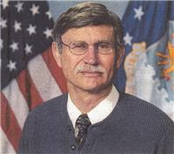Alvin "Bud" George Jordan, age 72, passed away on Tuesday, September 27, 2016. He was born on June 6, 1944 (D-Day) at Hendricks Army Airfield Hospital in Sebring, Florida. He was the son of a career Air Force family and first came to Eglin AFB in 1949. As an AF dependent, he grew up at Albrook AFB Panama Canal Zone; Spangdahlem AB, Germany; Alconbury AB, Bushy Park, London; and Lakenheath AB, England. He is survived by his wife and lifelong best friend, Janet Gayle Shaw; his son, John Curtis; and his Grandson, Caleb Austin. Al graduated from Choctawhatchee High School in 1962. He went on to the University of Florida, enrolling in the AFROTC program, and graduated with a BS degree in Biology and Chemistry. Upon graduation in 1966, Al was assigned to the 44th Strategic Missile Wing, Ellsworth AFB, SD, and was certified as a Minuteman ICBM Launch Control Officer while also becoming an Emergency War Operations instructor, a Crew Commander, and being promoted to Captain. He received an honorable discharge from the Air Force in 1971. Al returned to the University of Florida and completed a degree in Landscape Architecture, and was a member of the American Society of Landscape Architects. He worked 6 years with the City of Gainesville Department of Community Development, then re-entered Federal Service as a civilian in 1982 which included the 437th Civil Engineering Squadron at Charleston AFB, SC, the Southern Division Naval Facilities Engineering Command also at Charleston, and the Navy Public Works Center at NAS Pensacola, FL. In 1992, he accepted a position at Eglin AFB with the 96th CEG Environmental Management Division. Al retired with 30 years of Federal service December 2006 at the Air Force Armament Museum at Eglin AFB. In 1967, he married Janet Shaw, his high school sweetheart whom he met at Alconbury AB while attending high school at Lakenheath AB, England. An inseparable pair, they enjoyed spending time with their many friends traveling, being outdoors, experiencing nature, and selflessly serving others. Al loved God with all of his heart, and served as church shepherd for 9 years. He loved and appreciated God's creation, and shared God's love with others daily. He will be dearly missed by his family, friends, and church family. His love for God and others is eternal. There was a time of visitation held from 10:00-11:00am on Saturday, October 1, 2016, at Destin Church of Christ, 150 Beach Drive, Destin, FL with a Celebration of Life Service at 11:00 a.m. Graveside Services with Military Honors were at 1:30 p.m. at Heritage Gardens Cemetery, 2201 Partin Drive N, Niceville, FL. Memorial donations may be made in lieu of flowers to Rocky Bayou Christian School, Niceville, FL; Hope Medical Clinic, India Mission, Destin Church of Christ; or a charity of your choice in Al's name. You may go online to offer condolences to the family and sign the guestbook at www.heritagegardensfuneralhome.com. Heritage Gardens Funeral Home of Niceville is entrusted with the arrangements.
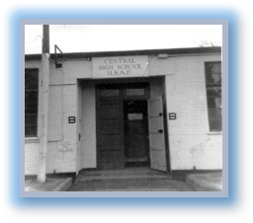

Memories of Bushy Park

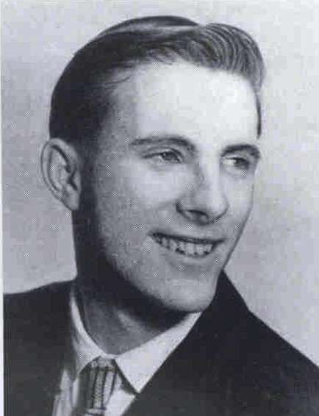

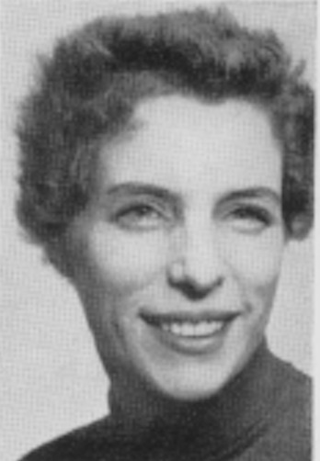

Mike Murphy (58)

My favorite teacher was Martha Kelly. I always enjoyed her classes.
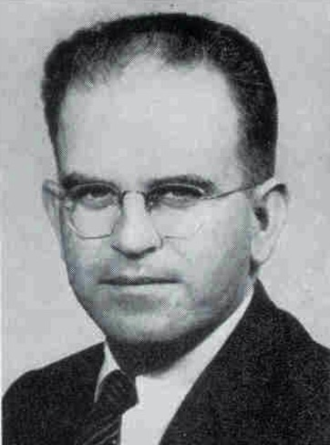My most unfavorable class was Mr. Law’s English class. Never could get the verbs and nouns, etc., lol. Never had to use them after school either, that I know of. Spent one year, 1955, in the dorm, then was a town student, when my father transferred to West Drayton and we lived in Staines.
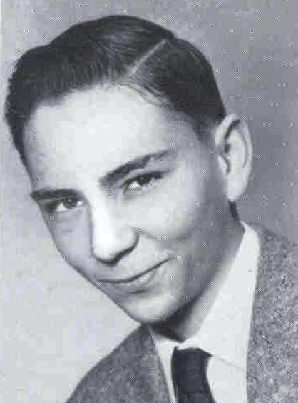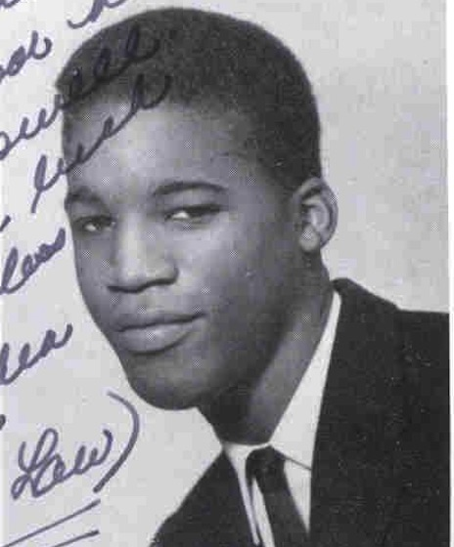My favorite high school classmates were Jerry Kelly and Julius Lloyd, a hell of a person. ....Overall, my 3 years at Bushy were the best.

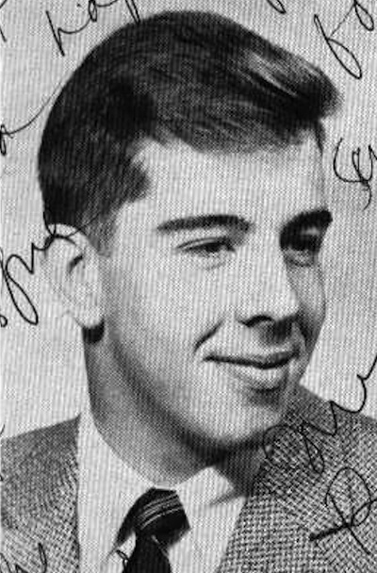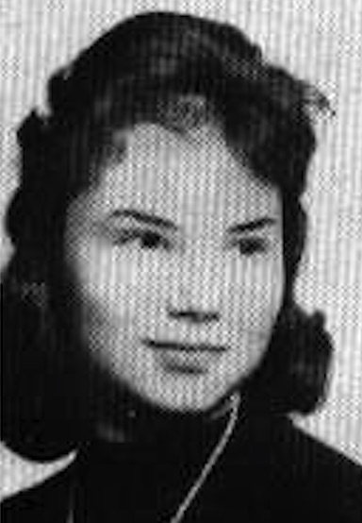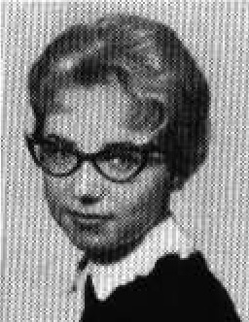
Vicki (Brown) Tidwell (61)

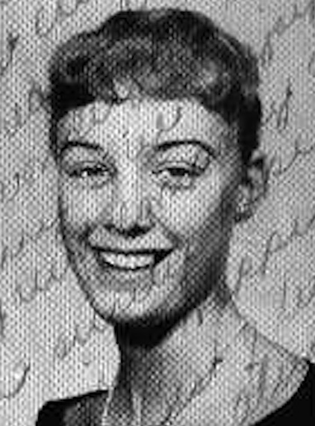I so appreciate the link from Jim Roberts (61) & Mary-Lou Quinn Benton (62) in this month’s Bushy Tales. Molly Hendrix (60) was a friend that I often thought of over the years after we were transferred to Texas in December, 1959. She was tall, very sweet, & spoke with the cutest Texas accent. I remember being on the street (in London, I think) with Molly, once, & she was asked by some locals if everyone in Texas was tall like she; & did she know how to ride a horse? Another memory was when we were in the CHS library & the British librarian asked if we planned on leaving, soon, since the library was closing. Molly said, “We’re fixin’ to.” The librarian got snippy & wanted to know just what she meant by “fixin’ to.” Molly was taken aback & couldn’t understand his reaction. (I have other fond memories of Molly.)
I was happy to discover “Bushy Tales” several years back; I hoped to learn about some of my old classmates. It wasn’t long before someone mentioned the airplane crash in Munich in December, 1960. I was devastated to learn that Molly was one of the UMMC students who died on that fateful day. I hope someone from her family will read this post on “Bushy Tales”. I want them to know that I loved Molly. She was one of the most unpretentious people I’ve ever had the joy to know.
(Side note: I married a Texan in 1962--& often say “fixin’ to,” myself, now.)

Letters to the Editor

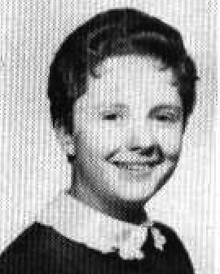

Toni Cooney (62) Clem
A Recent Return to London

I don’t know what it is about London, but something just keeps pulling me back. Even my husband, Plug, who celebrated his 75th birthday this past May with a cruise to various ports in the North and Baltic Seas, asked if we shouldn’t stop by London for a few days on the way home from our departure port in Amsterdam. We chose the cruise because he’s always wanted to see the Hermitage in St. Petersburg. But I think secretly he just wanted to go to London. He’s almost the same way about Paris. And if we’re headed to Paris, we have to stop in London. What is there that keeps pulling us back?
Is it that every time we go we see something new. That, like any great city you never really know everything there is to know about it. The things you think are familiar, like the National Portrait Museum (a personal favorite), every time I go I see something I had overlooked before. The homeless problem on Trafalgar seems to worsen. But at the same time, one can look in at St. Martin-in-the-Fields on the Square and see what the free lunchtime concert is. We went to the Choral Eucharist at St. Paul’s on Sunday, because I always like to visit and perhaps catch the choirs rehearsing. Our London friends said to avoid weekdays, because tickets are now 20 pounds. The boys choir sang, and I was pleased to note that the verger, the canon and several of the priests in the procession were women.
There is still fabulous theater. The hottest ticket in town is the Lily James (“Downton Abbey”) “Romeo and Juliet,” with Judi Dench and Derek Jacobi. We tried and they had one seat left for the next six months. They say the tickets aren’t half as ‘hot’ as the play.
There are some fabulous new restaurants, like ‘Chez Bruce,’ a Michelin-starred (one) French restaurant, where we actually had Plug’s birthday dinner with both London friends and a couple from home with whom we did the cruise. There’s a terrific Italian Tapas bar called Polpo (there may be two locations), and at Festival Hall a restaurant called Skylon worth visiting. BTW, the Southbank is a swinging place now, much more than the Fifties. If you’ve never been to the Tate Modern, it’s there.
I always like to have tea at Claridges, but we didn’t have time. As a matter of fact, we were there three days and didn’t have time to do a lot of the usual things, things that always remind me of when I lived there. We didn’t get to Harrods. I’ve been back to the store only once since Diana’s death in 1987. Mohamed Al-Fayed bought it in 1985, and following the death of his son with the Princess in 1987, he turned parts of it into a monument to them as a couple–which felt unseemly to a lot of shoppers. He also upped the tourist quotient: teddy bears in bearskin hats, tea cosies, Christmas ornaments, etc. Too much. He swore he’d never sell it, but he did in 2010, to Qatar Holdings, the sovereign wealth fund of the State of Qatar. It sold for $1.5 billion.
Because of the TV series, we did pop in to Selfridges, and it was as glamorous as ever. But my husband bought himself a sports coat at good old dependable Marks and Spencer. (Do you know there’s a Marks and Spencer in Hong Kong?)
Those of you who have been in the past few years know that you can’t walk past 10 Downing Street anymore. It’s blocked at both ends by thick iron gates and protected by both military and police, a situation caused more by terrorist threat than the crime rate, I’m sure. But they’ve opened up that warren of World War II offices close by in the basement of the UK’s administrative offices referred to as Whitehall. It was in there that Churchill, his aides and military leaders from all of the Allies gathered to strategize and wait for results to come in. Only a small group can go in at a time, but it’s worth the trip.
We found a book, Teddy Boys: A Concise History. I wanted to read up on something I remember well from our stay there (1957-60). It’s not particularly compelling, mostly interviews with some aging members of the fad, who were entranced with the clothes and the mystique that went with being called ‘Britain’s first youth cult of the mass media era.’ They weren’t tied to the introduction of rock ‘n roll into Britain, though they embraced it with fervor. Their first appearance was tied to the clothes and they were called the ‘New Edwardians.’ They were divided into two groups, one known as being vicious gangs, the other more interested in the dapper nature of the clothes. Members were proud of being called ‘working class aristocrats.’ (The book is by Ray Ferris and Julian Lord, if anyone is interested.)
Well, this may be boring to many of you, but you asked for ‘anything’ and this is ‘anything.’ Hahaha... until next time...Toni Cooney (62) Clem
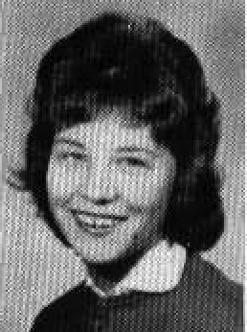

From Susan Miller (62) Dalberg:

Hi Guys: I don't know if any of you are on Facebook, but you may want to check this out. It's a group I belong to:

You're Probably a Military Brat If...

One of the members of that site has just taken a new post to document and save information about American Schools overseas. The Facility will be in Wichita, so if any of you have stuff you'd like to see preserved or exhibited there, (or ran out of room in your closets for, LOL), now you have a place for it (to donate). I wasn't a dormie, so I don't have much but a few pictures I'll happily share (already shared in newsletter, when Gary was alive), Still hanging on to yearbooks for a while, but there's a note inside for my kids to make sure if I pass over, a notice is put on here for anybody who wants 60 and 61.

“EVERYBODY—SOME EXCITING NEWS FOR ME, AND I HOPE FOR MANY OF YOU!
Dear Friends,
I am delighted to announce what I think is some pretty exciting news. I have accepted the offer of the post as Operations Manager for the American Overseas Schools Historical Society Archives in Wichita, Kansas. This amazing organization, also known as AOSHS, helps to preserve the history and heritage of our Department of Defense Dependent Schools, an amazing school system established and operating since the end of World War II, and overseas American schools worldwide that have had to close their doors.
AOSHS tells the unique stories of the several million children of U.S. military personnel and civilian employees who grew up attending schools outside the continental United States along with the hundreds of educators employed by the Department of Defense Education Activity (DoDEA). As some of you know from my previously shared posts, I was one of those students for most of my brat years while my father served in the Navy and we lived overseas in Hawaii, Alaska, Guam and London, England.

In the ensuing years, as you will read in the attached press release, a large number of schools have closed down. Thankfully, many have been able to package up some of their documentation such as yearbooks and other mementos (think banners, awards, trophies, photographs, etc) and consign them with the Archives.
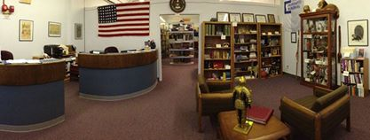

I will assist the wonderful board members—most of them former educators and administrators who worked in the school system—progress in their endeavor to bring greater awareness to this exceptional institution established in 1989 by Dr. Thomas Townsend Drysdale, Jr., to increase its visibility and membership to help protect our history, and coordinate both donations of school items as well as legacy and funding donations.

So, to those ends, please visit and follow our activities at AOSHS by checking in with us at http://l.facebook.com/l.php?u=http%3A%2F%2Fwww.aoshs.org%2F&h=9AQGcQB7OAQHLz8ZCmOlPLo1AQMjdc84l78Y2vU5MAHwv_w&enc=AZMzQ5pxkhhNxOEB5z-sxow4Q3AGFuEd8XFANoa0cjzuVJobAtyAqMWAAmeg5AlspmocVTjdxK6HmmOKoR1qiTp4hkwL24nWMKO_aoqDzU9BydtP1Q5sqCjUsxop_Cpuv8QtkvgyDw7dbDWXic9R4f05Lc2jFezNUH2_OP7i2zsvFg&s=1 and on Facebook at www.facebook.com/groups/169980156354700/ and www.facebook.com/AOSHSArchive/

Better yet, join us: http://aoshs.org/index.php/about-us/membership/ and come visit us in person—AOSHS has a fascinating collection of items! If you think you might be in town, just give me a heads up via email at aoshsoffice@sbcglobal.net and I can make sure I can show you specific items important to YOU.”

--FINIS--

