Issue #7 September 2016 Volume #16

Gary Schroeder (55), Founding Editor (1936-2016)
Bill Rumble, Editor email: BushyTales1@verizon.net
Pat (Terpening) Owen, Assistant Editor email: nemoamasa@sbcglobal.net
Visit the Bushy Park Website at http://www.bushypark.org/

CLASS REPRESENTATIVES
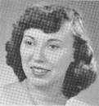

1953 – Jackie (Brown) Kenny

JKYKNY@aol.com

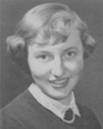

1954 – Betsy (Neff) Cote
betsycote@Atlanticbb.net

1955 – Volunteer Requested
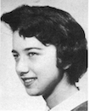

1956 – Edie (Williams) Wingate
WingW@aol.com

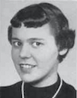

1957 – Shirley (Huff) Dulski
shuffy2@msn.com

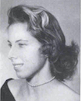

1958 – Pat (Terpening) Owen
nemoamasa@sbcglobal.net

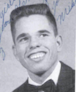1959 – John “Mike” Hall
MGHall@Q.com

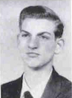
1960 – Ren Briggs
rpbjr@frontier.net

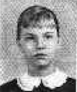
1961 – Betsy (Schley) Slepetz
bslepetz@comcast.net

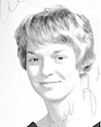
1962 – Dona (Hale) Ritchie

DonaRitchie@aol.com

ROSTER CHANGES

From: Pat Terpening (58) Owen

FOUND CLASSMATES

Carol Adamson (62) Powers
Pamela A. Hardin (62) Felton
Janice C. Hardin (61) Martin
Tommi Shuman (56) Zacharias
Catherine Shuman (58) Karsell
Willa Deavers (56) Hogue

_________________________________________________________________
A little reminder to all –if/when you change your email address, please let Pat Terpening nemoamasa@sbcglobal.net or me know, if you want to continue to receive the newsletter. Too many times we only find out when you send us an email saying you haven’t received the newsletter in few months. Thanks guys.
_____________________________________________________________________________
A 2016 Gathering of Bushy Park Students
We are having another Bushy Park Gathering. It has been 3 years since we last got together. You are all invited to attend - from the Class of ‘53 to the Class of ‘62. In the past, we have always had an outstanding time and we take home so many memories.
Time, it goes by so fast.
My father had a sign in his office that said it all. “Kill a little time today, for that is what Time is doing to you”. Please consider attending, before Time has passed you up. The Gathering is scheduled for (Sunday) October 9th to (Thursday) October 13th, in Las Vegas, NV. The contract is all signed, so all you have to do is contact me and I will send you the phone number and special code required to make your reservations at the group rate. We are receiving a special room rate of $42.00 a night. If you have any questions, please feel free to call or e/mail me. Hope to see you there!

I received a list from The Orleans of the people who have made their reservations for our LCHS Gathering in October. This is a reminder that the cutoff date is September 9th in order to get the room rate. I have attached the information with the phone number, group code number and group name.
If you have made your reservations and your name is not on the hotel list I received today, please contact me as soon as possible. It may be that the code did not get entered in correctly.
I hope that you are still planning on attending The Gathering, if not e/mail me and I will remove your name.
Thank You
Ren Briggs, Class of ‘60 rep. 928-758-2963 rpbjr@frontiernet.net
LCHS Las Vegas Gathering date: 8-15 update

Well, we are under way. I have signed the contract with The Orleans Hotel and Casino.
I have blocked out 30 rooms at the rate of $42.00 a night. The rate is for Sunday October 9th to Thursday October 13th. Now it’s up to you to reserve your rooms.
Reservations phone number is 800-675-3267 or on line at:

http://www.orleanscasino.com/groups
Group Code is A6LCC10
Group Name is LCHS Gathering

Without the Group Code and Group Name you will not get the room rate. The cutoff date is 9-9-2016. Room cancellation must be 48 hours prior to arrival. Be advised that there are resort fees mandatory by State Law that are added to your room cost. Sorry about that.
Accommodation for Disabled Persons. The Hotel shall take all reasonable steps to ensure the accessibility for disabled attendees. You must advise the Hotel prior to arrival of the anticipated needs for such accommodations.
At this date you will note that we have 22 who are planning on attending. We only need 8 more to fulfill the contract. I am sure that will not be a problem. The key is you make your reservations as soon as you can.
I will send out additional information as I get it. If you have any questions, please contact me.
Ren Briggs 928-758-2963 e/mail rpbjr@frontiernet.net

________________________________

Classmates Who Have Transferred To The Eternal Duty Station

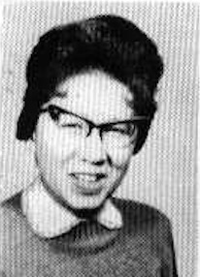Marcia Anthony 1944 - 1960 (February 8, 1960) Class 1962

Died at a London infirmary (Harrow, Middlesex), England , Marcia Lee Anthony, age 15. Survived by her parents, Major and Mrs. William Harold Anthony, brother, William H. Anthony, Jr., Grandparents Mr. and Mrs. W. Clyde Thomas of Nashville, TN and Mr. & Mrs. H. M. Williams of Sherman, TX. Remains will arrive early Friday morning and will be conveyed to Marshall Donnelly Combs, 201 25th Ave N, where services will be conducted at 11o'clock Friday morning by the Rev. George Wilson of Phoenix, AZ. Pallbearers are Col. Thomas R. Taggart, LTC. William H. Humphries, both of Washington, DC., Paul Bracey, James Baldeger, Fred B. Shelton and Ervin T. Sain. Internment - Woodlawn Memorial Park.
From The Tennessean, Nashville, TN, Pg 39, Thursday Feb, 11, 1960

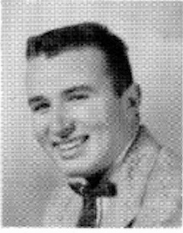
Joel R. Crenshaw 1938-1997 (Class of 1956)
From the Washington Post
Consulting Executive

Joel R. Crenshaw, 58, an airport development consultant who was president and board chairman of Interair Development Corp. of Great Falls, Va., died of cardiopulmonary arrest Jan. 31 at Fairfax Hospital. He lived in Great Falls.

Dr. Crenshaw, a Washington native, was a graduate of George Washington University, where he also received a master's degree in philosophy and a doctorate in economics.

From 1965 to 1969, he was economic services director of the Airport Operations Council International, a trade organization. In 1969 and 1970, he was management contract chief for the Federal Aviation Administration's national capital airports bureau. Before starting Interair in 1984, he also served as president of Thompson-Crenshaw Inc., another Great Falls airport and management consulting concern.

Dr. Crenshaw had been an officer of the American Association of Airport Executives and Administrators, publisher of the journal Aviation Monitor and a member of the Omicron Delta Epsilon economics honor society. He was the author of a Transportation Department policy studies dealing with such subjects as federal aid to airports.

His wife, the former Patricia Mann, died in 1995. Survivors include a son, Kenneth G., of Great Falls; two daughters, Kymberly G. Crenshaw of Ashburn and Kerry G. Crenshaw of Great Falls; and a brother, David, of Frederick, Md.

Van T. Ostrom - 1944 - 2012 (Class of 1962) (No photo available)

Van T. Ostrom II, nicknamed Chip, 67, of Fairfield (CA) passed away at his home, Thursday, March 1, 2012.
Van was born March 8, 1944, in Bakersfield, CA, and was raised in Fairfield. He attended Fairfield Elementary, the United Methodist Church and the local Boy Scouts in his youth. He lived in Germany and England during his high school years, as his father, a career U.S. Air Force man, was serving a tour of duty there. After graduating from Sacramento State College, he served in the U.S. army for a few years. He had a lifelong career as an investigator for the California Employment Department retiring from the Fairfield branch in 2002. He married Thong Poon Komchai, nicknamed Toni, on June 19, 1998, in Fairfield.
Favorite activities of Van's were fishing, hunting, collecting postage stamps and painting with watercolors. He especially enjoyed his annual trips to Loretto in Baja, Mexico, where he and his father fished. He frequented local swap meets, delighting in finds of silver jewelry, which he distributed among the family. He loved doing for others, and in recent years helped in the Highway International Christian Fellowship.
Among the survivors are his wife and sister, Sue Stout, of Grants Pass, OR. Van's parents Virginia and Van Ostrom, passed away in Grants Pass before him in 2004 and 2005.
A memorial service will be held at 11 a.m. on Saturday, March 10, 2012 at The Highway International Christian Fellowship, 1319A W. Texas St. in Fairfield.

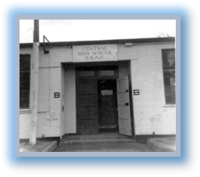

Memories of Bushy Park

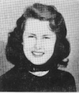Susie Talbot (53) Cameron

House Mothers
This is 1952...64 years have passed, so I do not remember names or how many, but we had a few, because many did not know how to manage these American teenagers...finally we got two and they took us places...The place I remember the best was to the Palladium to see Dean Martin and Jerry Lewis in person...somehow they were able to take us backstage to their dressing room...Jerry Lewis was very serious and Dean Martin was very nice to us and we visited them for over half an hour...We liked our dorm which was an old English house...When we went back in 2003 we found it had been torn down.
_______________________________
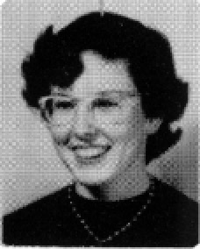

Nancy Reed (56) Gesswein

My Favorite Teacher at Bushy Park in London

When my dad got duty in London, England, we moved to Hampstead Garden Suburb near the Golder’s Green station on the tube. Soon after my dad walked me up to the nearest school, like any American father might do in the US. This school was a British Girls’ School called Henrietta Barnett’s School for Girls, a private school, meaning a government run academic school for any girl who could pass their exams. I took some tests and very soon, I was the only American in this British school. It was an experience of fun, learning, and culture shock-both for the teachers and for me. I also felt I lost my status as an American teen and was issued an ugly, navy blue uniform to show my new identity.

We had come from the Isle of Palms, near Charleston, SC, where I had acquired a southern accent. At first few Brits could understand me. I was enrolled in twelve classes including Latin III, religion, art, gymnastics and “the maths”. Some subjects I did well in and some I had no background for and did poorly. The worst was “the maths” with daily work in algebra, trigonometry, geometry, or basic arithmetic with British money and measurements which was confusing.

The next year I got a surprise! Since I would be a senior when I got back to the States, I was moved to Bushy Park High School where “the powers that be” decided how to make the things I had taken in the British school fit with what I would take at Bushy Park to get my transcript adapted. The goal was to have my 16 credits to graduate on time. My senior year would be a fourth high school somewhere in the US the following year. This was a very important gift. No one wants to spend 5 years in high school!

When I was at Bushy Park my sister, Bette Lu, and I were town students and we rode on the bus for an hour each way. Kenton Pattie, Don Cruz, and the Cramm girls lived near. Robin and Janie were good friends as was Kenton who had spent many years in a British boys’ school himself. There were other American students; Pat Miller, Ken Robie, Ruth Lund, and John Peterson in our area. With the gift of American friends also came the Teen Center at the Barbara Hutton house in London. I took the tube for those teen events. (The tube to me was the greatest thing I knew about in London! I could go anywhere!)

At Bushy Park I had all male teachers; Mr. Dickinson-English, Mr. Francis-US history, Mr. Rosen-French, Mr. Terry-Algebra, and later Coach Cannon-US history. (Was that someone’s idea of a joke after the girls’ school?) Miss Harris in art was my only female teacher I knew. She sponsored the art club which was great!

Mr. Terry had the hardest job with me. I had only taken Algebra one day a week in the British school. (That would be only 52 days if I went to algebra every week all year.) He helped me pass Algebra II in his class to get credit for Algebra I and II. That was adjusting my transcript. He was very kind as he guided me with that class that was so challenging for me.

My favorite teacher was Mr. Francis. He was cute, young, and seemed like one of us. He was very serious about history and had excellent charts, diagrams, and time lines to make history slide into my brain more easily. He also explained how certain historic events came to be. I had spent the previous 3 years learning US history, especially the civil war part first in Philadelphia-PA, near Charleston-SC, and then the British point of view. I learned primarily that US history varied a great deal depending on who wrote the book and who taught the class.

Robin and I were good students for Mr. Francis, who occasionally rode our bus home. One day Mr. Francis told the class about a Louis the XV bed that he had just purchased. We were fascinated. Robin and I questioned Mr. Francis about the bed. Finally, he invited us to visit and see this prize possession. Since his apartment was near where we lived, we made a plan to visit him. I do not know about Robin, but when I told my parents Robin and I were invited to visit Mr. Francis and see his Louis the XV bed. My dad hit the roof. Finally, we scraped dad off the ceiling and both Robin and I got permission to visit Mr. Francis and see the bed. It was a purely academic adventure to be sure. It was great to have him respect our intelligence enough to invite us to see his treasure.

Another time Mr. Francis and Mr. Rosen took eleven of Mr. Rosen’s French students to Paris for a weekend. (We also had a female sponsor, Mrs. Bidleman, for that trip, but she was sick the whole time and we never saw her except on the plane.) Mr. Francis and Mr. Rosen kept us on the go morning, noon, and night. We even visited L’ Opera. The music was grand, costuming divine, and the scenes were even scented with sprays. Later that night we ate the traditional onion soup. We were short of funds and the garcons chased us for the tip which we did not have. It was a fun trip!

After that the men sent us off to bed and went out on their own. We, with some French bread and several bottles of wine had a slumber party in one of our rooms and “practiced our French”.

When we flew back to London we each carried a loaf of French bread under one arm.

When I was invited into National Honor Society I was thrilled, but it meant changing from Mr. Francis’ class. It was hard to make the switch, even to participate in the NHS sessions. Mr. Francis, for his part, was kind enough to give me the quarter exam to complete my time with him on the bus, orally, on the way home one day.

Then some other NHS students and I were sent to Coach Cannon’s history class. (We were not good students for Coach Cannon, in fact we were awful-he gave us our A’s but remarked that we deserved C’s.) He was correct-poor guy.

Truly all my Bushy Park teachers were great! What makes Mr. Francis stand out is that I knew him on the bus, which was informal, and in the classroom, which was good teaching.

Those are good memories!

_______________________________________________________________________________________________________________

Editor’s Note:

My wife and I just got back last week from a trip to the UK. We flew to London and joined a cruise ship in Southampton for a cruise around the British Isles and Ireland. The first day we were in a hotel in London a few blocks from the Houses of Parliament and Westminster Abbey. Also very near New Scotland Yard HQ. The crowds of tourists were huuuuuge! Nothing like when I lived in England in 1954-55!

The next day our bus to Southampton drove down Knightsbridge and passed the end of the street on which we lived, Wilton Place. We lived just over a block south of Knightsbridge. My brothers and I caught the bus to Bushy Park on Knightsbridge just past our street.
We then traveled along Brompton Road passed Harrod’s, with another huge crown waiting for them to open. It is about 9 minutes’ walk from where we lived.

The bus continued to follow the route our school bus traveled through Kensington, Chiswick, Kew, Richmond, Twickenham at which point I saw a sign in the direction of Teddington. Alas, that is where we continued southwest to the motorway for Southampton. I spent many hours on that route – twice a day for the time we were there.

So much has changed, but so much is still as it was over 60 years ago.

We were traveling with one of my cousins and his wife. He graduated from the US Naval Academy and was stationed on a guided missile submarine in Holy Loch, Scotland. Our tour out of the Scottish port of Greenock, near Glasgow, took us alongside Loch Loman and then over a pass and back alongside Holy Loch. He had not been back there since he left for the last time 42 years ago. Some nostalgia for my cousin. He had no idea we would pass right through the area where he had spent so much time over 40 years ago.

In the small world category – my cousin served on the USS Abraham Lincoln (SSBN-602). When he first reported aboard, he met with the Captain in the Wardroom. On the wall was a picture of a few people taken at the time the ship was christened and launched. My cousin pointed out to the Captain that one of the officers in this picture was his uncle – my father. He was the Shipyard Commander, Portsmouth (NH) Naval Shipyard, when the Abraham Lincoln was built and launched.

Bill Rumble (57)

Letters to the Editor

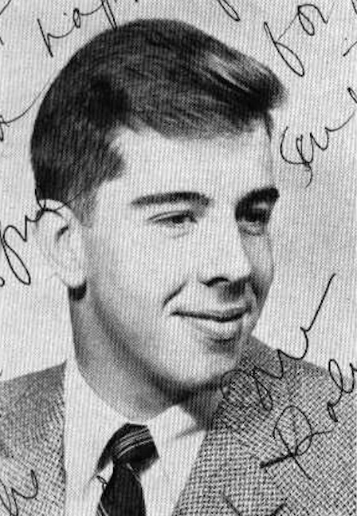Thought the link below might be newsworthy:

It was sent to me by my 1961 prom date, Mary Lou Quin (62) Benton, with whom I stay in touch and visit periodically

Jim Roberts, '61

From: Jim Roberts
Date: August 2, 2016
To: Mary-Lou Benton
Subject: Re: Site about Munich

You should pass this on to the new editor of Bushy Tales
I remember the crash.
I was a senior at B P at home for the holidays at Upper Heyford, where my father was deputy base commander
72 months later I was flying a similar plane in Vietnam

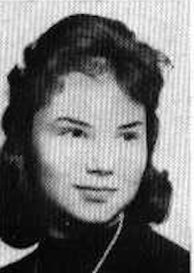On Aug 2, 2016, at 9:06 PM, Mary-Lou Benton wrote:

The only people I know who would know about this tragic crash in
Munich.

Begin forwarded message:

Date: August 2, 2016 at 4:35:59 PM EDT
To: Mary-Lou Benton
Subject: Site about Munich

Site about crash

https://passportsandpedagogy.wordpress.com/2012/08/20/1960-tragedy-in-munich-germany/

________________________________

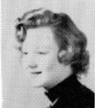
Carolyn “Tish” DEVAUGHN (56) FLOYD

Bill:

I am trying again so hope this goes through. I think he was Class of 57, but not sure.
Tish

[Editor’s Note: William Vance was Class of 56]
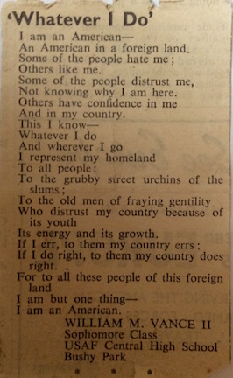

Here is a really old magazine cover that I have successfully saved forever, but don't know
why. The second page will be coming shortly, hopefully! Regards! Tish

[L-R – Barbara Smith (56), Tim Sutherland (56), Carolyn “Tish” Devaughn Floyd (56)]

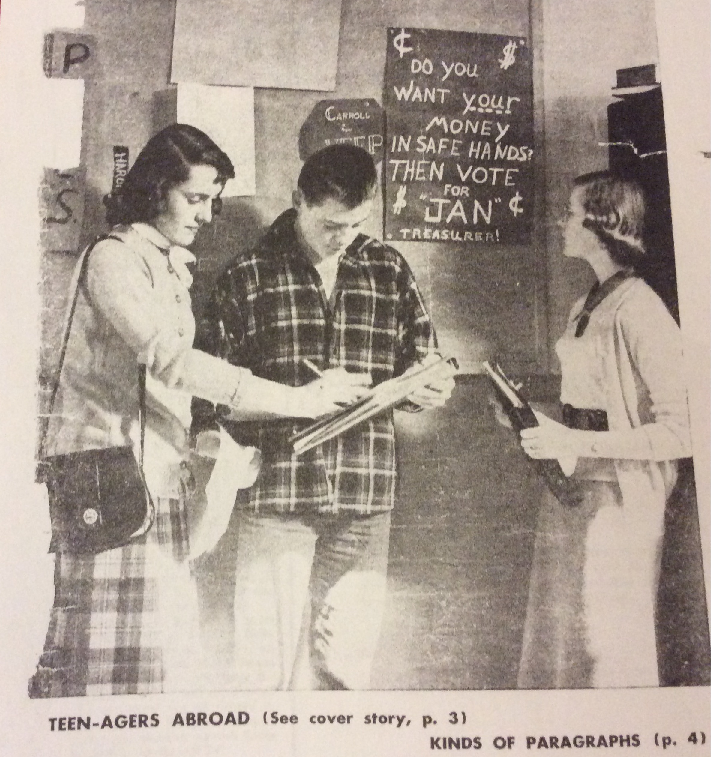

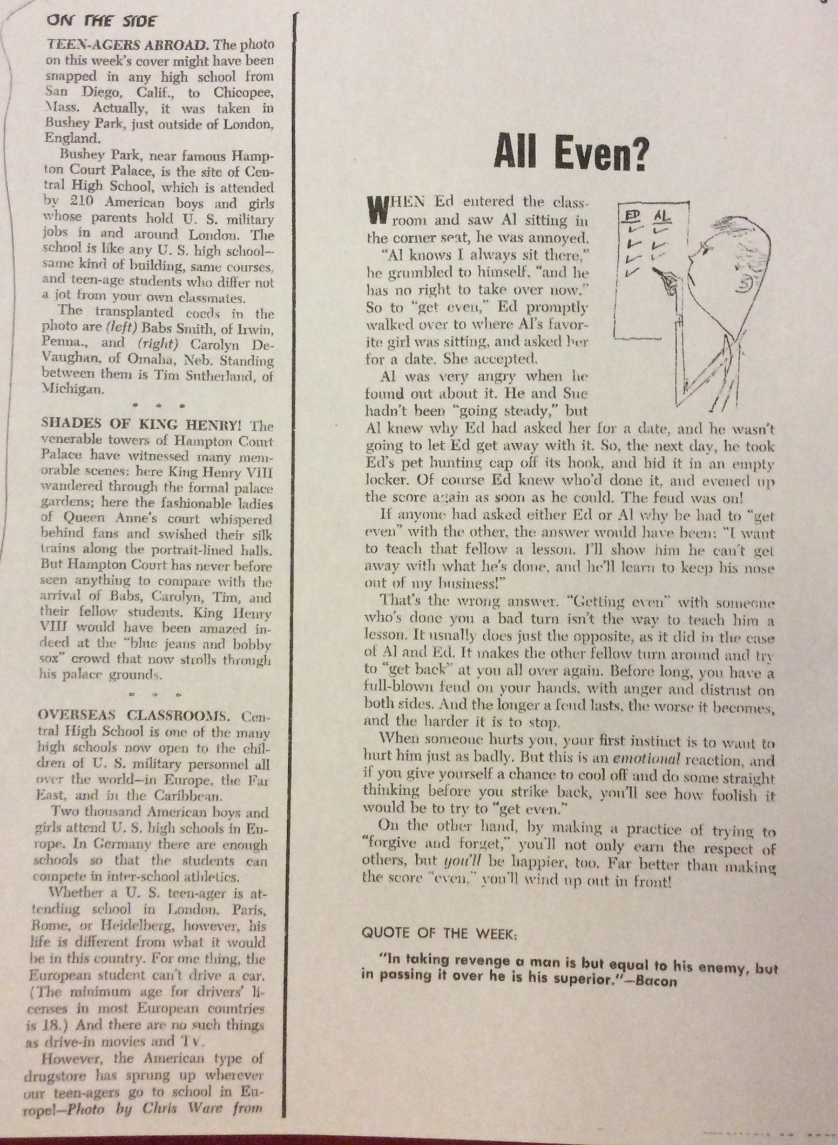

______________________

From Ron Crowe (64)

Update on Jerry Donahue (64)

He is doing very well considering the seriousness of the stroke. Frank Badami virtually saved his life since he was the first person to get to him and get him to the closest hospital, Hollywood Presbyterian.

Jerry is now in a rehab center receiving daily Physical, Occupational, and Speech Therapy. He's paralyzed on the right side and cannot talk yet but manages to speak some words. He uses his left arm/hand to spell out letters in the air and is doing extremely well writing on paper with his left hand - he is right handed.

Physical and Occupational Therapy has been remarkable and Jerry doesn't want to stop at the end of the one hour sessions. Yesterday he was able to put his full weight on his right leg and actually take three baby steps with his left foot. While this doesn't sound like much it is tremendous since Jerry has only been at the facility one week.

Speech Therapy is also quite remarkable and he is able to harmonize with music from his bands, "Fairport Convention," "The Gathering," and "Fotheringay," plus some U2 songs thrown in. While he can't play the guitar YET he fingers out notes on his leg as if he were sliding up and down the fretboard.

I have to share this funny event with you because you know Jerry as well as I do. Part of the Speech Therapy is forming sounds with his lips ... O for example ... and puckering your lips as though you were going to kiss someone. The first day his therapist asked him to, "pucker up as though you are going to kiss me". Jerry leaned over and gave her an unexpected kiss! They both cracked up laughing and now the kiss is part of the morning ritual with this one therapist.

I see Jerry every day except Saturdays when we visit my mother-in-law who is in assisted living. His daughter Kristina, his only blood relative, has a seven-month baby and she can’t be here as often as I can. She lives in the New York city area and has flown out here to Los Angeles twice, spending a week each time before going home for fresh baby clothes and clothes for herself.

As Jerry progresses I will do my best to keep you up to date on how he is recuperating. And if you want to send him a get well card or letter you can send them to me: 237 N. Niagara St., Burbank, CA 91505 and I will happily pass them on. He has received numerous cards from all over the world since "Guitar World" magazine wrote an article about his stroke and word travels fast in the music industry.

Keep Jerry and Pam Palmer Martin's husband, John, in your thoughts and prayers. They need our strength to help them through their medical challenges.

--FINIS--

